UNITED STATES

SECURITIES AND EXCHANGE COMMISSION

Washington, D.C. 20549

SCHEDULE 14A

Proxy Statement Pursuant to Section 14(a) of the

Securities Exchange Act of 1934

Filed by the Registrant ☑

Filed by a Party other than the Registrant ☐

Check the appropriate box:

- Preliminary Proxy Statement

- Confidential, for Use of the Commission Only (as permitted by Rule 14a-6(e)(2)) ☑ Definitive Proxy Statement
- Definitive Additional Materials

- Soliciting Material under §240.14a-12

Commvault Systems, Inc.

(Name of Registrant as Specified In Its Charter)

(Name of Person(s) Filing Proxy Statement, if other than the Registrant)

Payment of Filing Fee (Check all boxes that apply):

- No fee required.

- Fee paid previously with preliminary materials.

- Fee computed on table in exhibit required by Item 25(b) per Exchange Act Rules 14a-6(i)(1) and 0-11





Commvault Systems, Inc.

1 Commvault Way

Tinton Falls, New Jersey 07724

- 870-4000 June 25, 2024
Fellow Commvault stockholder:

Whether you are an executive assessing a cyber resilience solution or an investor evaluating a stock, you want to choose a company you can rely on to deliver results. In fiscal year 2024, Commvault delivered while achieving a breakout year.

As a leader in our industry, we solve our customers’ hard problems in an increasingly difficult world, accelerate our growth, and deliver returns for investors like you. It’s a responsibility we take very seriously.

First, we pride ourselves on innovation. This goes beyond delivering the best-in-class Commvault Cloud platform to help customers be resilient following a cyberattack or catastrophic event. We are also responsible in how we innovate our patented portfolio, including our unrivaled Cleanroom Recovery and newly acquired Appranix offerings. Which is why we have engineered responsible AI capabilities deep into our platform to enhance resilience without jeopardizing our customers’ data. After all, our customers data has and always will be our foremost responsibility.

We will continue to focus on responsible growth. Last fiscal year, we increased total revenue by 7% to $839 million, which was led by 23% growth in subscription revenue. Total annual recurring revenue “ARR” grew 15% to $770 million. This was fueled by our high growth software-as-a-service platform, which crossed over 5,000 customers and ended the year with $168 million in ARR. With the unrelenting rise of cyberattacks, we believe this growth will continue in fiscal year 2025.

Which brings us to our third tenet – it is our responsibility to deliver returns for our investors. Our dedication to execution and responsible growth enabled us to deliver 21.1% non-GAAP EBIT margins while returning 92% of free cash flow, or $184 million, back to stockholders in share repurchases. Our subscription model and focus on ARR as a primary measure of our business gives us the confidence to share our aspiration of $1 billion in total ARR in fiscal year 2026.

I would like to thank CEO Sanjay Mirchandani and the company’s leadership team and employees for making recovery and resilience a reality while staying committed to delivering responsible growth. And thank you – our stockholders – for your strong support of Commvault.

Sincerely,


Nicholas Adamo
Chairman of the Board



Time and Date: |  | Location: |  | Record Date:
Thursday, August 8, 2024 |  | Virtual only |  | June 13, 2024
10:00 a.m., Eastern Time |  | https://ir.commvault.com/news-and-events/annual-
 |  | meeting

It is my pleasure to notify our stockholders of our 2024 Annual Meeting. We look forward to your participation. The purposes of the meeting are:
- To elect nine directors for one-year terms;

- To approve, on an advisory basis, Commvault’s executive compensation;

- To ratify the appointment of Ernst & Young LLP as Commvault’s independent public accountants for the fiscal year ending March 31, 2025;
- To transact such other business as may properly come before the meeting, or any adjournment or postponement thereof.

Only stockholders of record as of the Record Date are entitled to notice of, and to vote at, the Annual Meeting and any adjournment or postponement thereof. We will mail a Notice Regarding the Availability of Proxy Materials to stockholders of record on or before June 13, 2024, so you can access our proxy materials online or request paper copies of these materials.

For information about how to access the virtual meeting, and what to do if you have technical difficulties, please see “Additional Information about the Annual Meeting.”

If you vote in advance using our telephone or Internet voting procedures or by sending in your proxy card, you may still attend and vote at the Annual Meeting.

A list of stockholders entitled to vote at the Annual Meeting will be available for examination by stockholders during the ten days preceding the meeting. Information regarding how to examine the stockholder list is available at the meeting website at https://ir.commvault.com/news-and-events/annual-meeting.

Important Notice Regarding the Availability of Proxy Materials for the Meeting to be held on August 8, 2024: This proxy statement and our annual report to stockholders are available at www.edocumentview.com/CVLT.

By Order of the Board of Directors


Danielle Sheer

Chief Legal and Trust Officer

June 25, 2024

2 COMMVAULT SYSTEMS, INC. | 2024 PROXY STATEMENT

How to Vote:


Online During
the Meeting

Attend the Annual Meeting virtually at
https://ir.commvault.com/news-and-
events/annual-meeting and follow the instructions on the website


Online Before
the Meeting

Visit www.investorvote.com/CVLT and finish voting before 3:00 a.m. EST on August 7, 2024.


Mail

Sign, date and return your proxy card in the enclosed envelope


Telephone

Call the telephone number on your proxy card

Proxy Summary |  |  |  |  |  |  |  |  |  |  |  |  |  |  |  |  |  |  | 4
 | What’s New |  |  |  |  |  |  |  |  |  |  |  |  |  |  |  |  |  | 4
 | Election of Directors |  |  |  |  |  |  |  |  |  |  |  |  |  |  |  |  |  | 5
 | Diversity and Tenure of the Board |  |  |  |  |  |  |  |  |  |  |  |  |  |  |  |  |  | 5
 | Fiscal 2024 Financial Highlights |  |  |  |  |  |  |  |  |  |  |  |  |  |  |  |  |  | 6
 | Governance Highlights |  |  |  |  |  |  |  |  |  |  |  |  |  |  |  |  |  | 7
 | Executive Compensation Highlights |  |  |  |  |  |  |  |  |  |  |  |  |  |  |  |  |  | 8
 | Environmental, Social and Governance Developments |  |  |  |  |  |  |  |  |  |  |  |  |  |  |  |  |  | 9
Proposal No. 1: Election of Directors |  |  |  |  |  |  |  |  |  |  |  |  |  |  |  |  |  |  | 10
 | Director Independence |  |  |  |  |  |  |  |  |  |  |  |  |  |  |  |  |  | 10
 | Board Diversity |  |  |  |  |  |  |  |  |  |  |  |  |  |  |  |  |  | 11
 | Nominees for Election |  |  |  |  |  |  |  |  |  |  |  |  |  |  |  |  |  | 12
 | Majority Vote Standard and Resignation Policy in Director |  |  |  |  |  |  |  |  |  |  |  |  |  |  |  |  |  | 16
 | Elections |  |  |  |  |  |  |  |  |  |  |  |  |  |  |  |  |  | 16
Corporate Governance |  |  |  |  |  |  |  |  |  |  |  |  |  |  |  |  |  |  | 17
 | Overview |  |  |  |  |  |  |  |  |  |  |  |  |  |  |  |  |  | 17
 | Cybersecurity |  |  |  |  |  |  |  |  |  |  |  |  |  |  |  |  |  | 18
 | Board Leadership Structure |  |  |  |  |  |  |  |  |  |  |  |  |  |  |  |  |  | 18
 | Board Oversight of Risk |  |  |  |  |  |  |  |  |  |  |  |  |  |  |  |  |  | 19
 | Stockholder Engagement |  |  |  |  |  |  |  |  |  |  |  |  |  |  |  |  |  | 20
 | How We Choose Directors |  |  |  |  |  |  |  |  |  |  |  |  |  |  |  |  |  | 20

3 COMMVAULT SYSTEMS, INC. | 2024 PROXY STATEMENT

Board Committees


Meetings of the Board

How to Contact Our Board

Governance Documents

Transactions With Related Persons

Director Compensation

Stock Ownership Guidelines for Independent Directors

Security Ownership of Management and Certain Beneficial Owners

Proposal No. 2: Advisory Vote on Commvault’s Executive Compensation

Executive Compensation

Talent Management and Compensation Committee Report

Audit Committee Report

Proposal No. 3: Ratification of the Appointment of Independent Auditors

Audit, Audit-Related, Tax, and All Other Fees

Policy on Audit Committee Pre-Approval of Audit and Non-Audit Services of Independent Auditor

Additional Information About the Annual Meeting

Annex A: Reconciliation of GAAP to Non-GAAP Financial Measures

21

22

22

23

23

24

25

26

28

29

40

52

53

53

54

55

59

Table of Contents


This proxy summary highlights information contained elsewhere in this proxy statement. It does not contain all the information that you should consider. Please read the entire proxy statement carefully before voting. This proxy statement is first being made available to stockholders on or about June 25, 2024.

 | Time and Date: |  | Location: |  |  | Record Date:
 | Thursday, August 8, 2024 |  | Virtual only |  |  | June 13, 2024
 | 10:00 a.m., Eastern Time |  | https://ir.commvault.com/news-and-events/annual-
 |  |  | meeting
MEETING AGENDA
 | Proposal |  |  | Board’s voting |  | For more
 |  |  | recommendation |  |  | information
 | Election of directors |  | ✓ |  | FOR each | Page 10
 |  |  |  |  | nominee | Page 10
 | Advisory vote on Commvault’s executive compensation |  | ✓ |  | FOR | Page 28
 | Ratification of independent auditors |  | ✓ |  | FOR | Page 53

What’s New

- We adopted a clawback policy which is compliant with the Dodd-Frank Act.

- We established our Enterprise Risk Management Committee comprised of senior management to address risks the Company faces in our ever-evolving world.

- We established our Cybersecurity Oversight Committee dedicated to cybersecurity response plans.

- We adopted our Principles for Responsible AI guidelines.

- We published a refreshed Environmental, Social, and Governance report, including the results of our inaugural Greenhouse Gas (“GHG”) emissions assessment.

4 COMMVAULT SYSTEMS, INC. | 2024 PROXY STATEMENT

Table of Contents

PROXY SUMMARY | ELECTION OF DIRECTORS

Election of Directors

The following table shows information about our director nominees. All of our directors and nominees are independent except Mr. Mirchandani, Commvault’s President and Chief Executive Officer (“CEO”).

 |  |  |  |  |  | Committees
 |  |  |  |  | Nominations |  | Talent
 |  | Director |  |  |  |  | Management
 | Age | Director | Occupation and Background | Audit | and | Operating | and
 | Age | Since | Occupation and Background | Audit | Governance | Operating | Compensation
NOMINEES
Nicholas Adamo, | 60 | 2018 | Founder and President of Making a Mark, Inc.
Chair of the Board
Martha H. Bejar | 62 | 2018 | Senior Partner, Dagrosa Capital LLC and co-founder
 |  |  | and Chief Executive Officer of Red Bison Advisory | n | n
 |  |  | Group, LLC
Keith Geeslin | 71 | 1996 | Partner, Francisco Partners |  |  | n | n
Vivie “YY” Lee | 57 | 2018 | Former Senior Vice President and Chief Strategy |  | n |  | n
 |  |  | Officer, Anaplan
Sanjay Mirchandani | 60 | 2019 | President and Chief Executive Officer, Commvault
 |  |  | Systems

Charles Moran | 69 | 2018 | Founder and former Chief Executive Officer and
 |  |  | President, Skillsoft Plc.
Allison Pickens | 39 | 2020 | Founder and General Partner of the New Normal
 |  |  | Fund
Shane Sanders | 61 | 2022 | Former Senior Vice President, Verizon
 |  |  | Communications

n n

n n

n n n

Arlen Shenkman | 53 | 2020 | President of Boomi, Inc. |  | n | n
Number of Directors |  |  | 4 | 4 | 3 | 4
 |  |  | n Committee Chair |  | n Committee Member

Diversity and Tenure of the Board
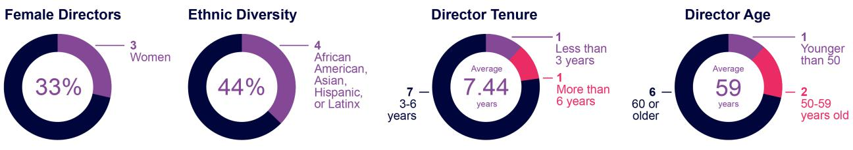

5 COMMVAULT SYSTEMS, INC. | 2024 PROXY STATEMENT

Table of Contents

PROXY SUMMARY | FISCAL 2024 FINANCIAL HIGHLIGHTS

Fiscal 2024 Financial Highlights

Fiscal 2024 was a breakout year for Commvault, highlighted by notable increases in revenues, annual recurring revenue (“ARR”)⁽¹⁾, subscription ARR⁽¹⁾, income from operations (EBIT), and free cash flow (“FCF”)⁽²⁾. Our stock price rose by 79% from fiscal 2023, complemented by consistent capital returns through strategic share repurchases. The following amounts are shown in millions, except stock price data:
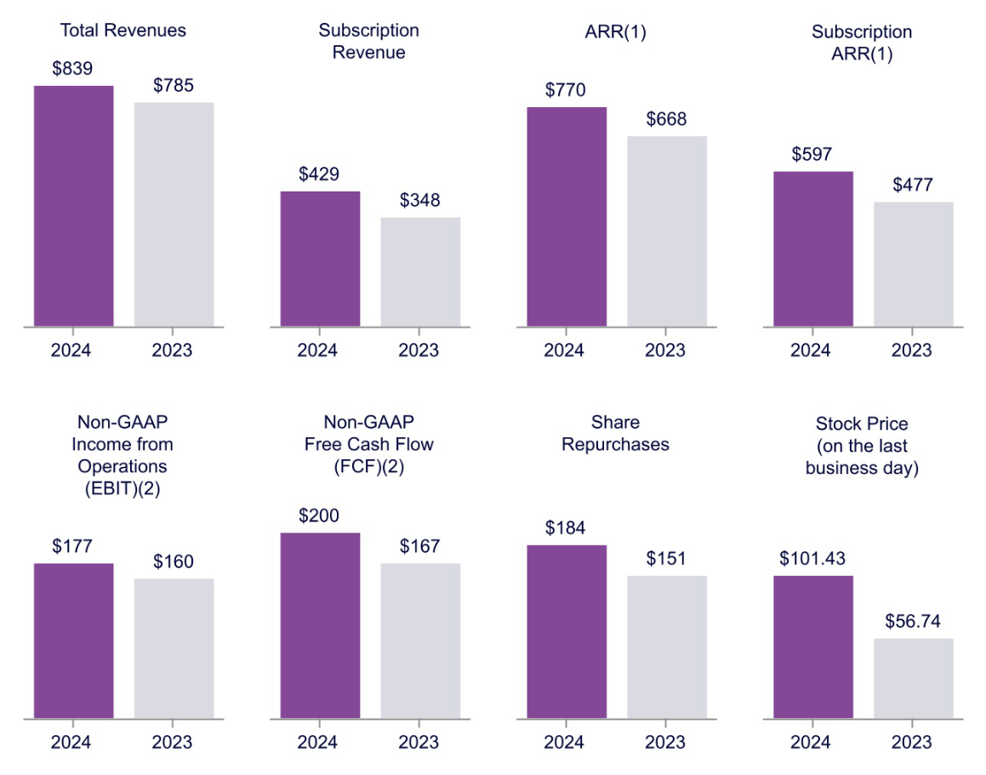

- Annualized recurring revenue (“ARR”) is defined as the annualized recurring value of all active contracts at the end of a reporting period. It includes the following contract types: subscription (including term licenses, software-as-a-service (“SaaS”) and utility software), maintenance contracts related to perpetual licenses, other extended maintenance contracts (enterprise support), and managed services. It excludes any element of the arrangement that is not expected to recur, primarily perpetual licenses and most professional services. Subscription ARR includes only term licenses, SaaS and utility software arrangements. Contracts are annualized by dividing the total contract value by the number of days in the contract term, then multiplying by 365.

ARR should be viewed independently of GAAP revenue, deferred revenue and unbilled revenue and is not intended to be combined with or to replace those items. ARR is not a forecast of future revenue. Management believes that reviewing this metric, in addition to GAAP results, helps investors and financial analysts understand the value of Commvault's recurring revenue streams presented on an annualized basis.

- Please see “Reconciliation of GAAP to Non-GAAP Financial Measures” in Annex A for additional information about our non-GAAP financial measures. Our GAAP income/(loss) from operations (EBIT) was $75 million and $(16) million in fiscal years 2024 and 2023, respectively. Our GAAP cash provided by operating activities was $204 million and $170 million in fiscal years 2024 and 2023, respectively.

6 COMMVAULT SYSTEMS, INC. | 2024 PROXY STATEMENT

Table of Contents

PROXY SUMMARY | GOVERNANCE HIGHLIGHTS

Governance Highlights

Commvault is committed to excellence in corporate governance. We have recently strengthened several of our policies and practices to demonstrate this commitment, including those summarized below.

Enterprise Risk. We established our Enterprise Risk Management Committee (the “ERMC”) comprised of senior management. The ERMC is responsible for the implementation, maintenance, and execution of our enterprise risk management program. The ERMC updates the Audit Committee and Board of Directors on a quarterly basis and as needed.

Cybersecurity. We established our Cybersecurity Oversight Team (the “CSOT”) dedicated to overseeing the significant operational decisions in the event of an active cybersecurity incident. The CSOT is comprised of senior management and our Audit Committee Chair is invited to the CSOT’s regular meetings to provide counsel and foster productive communication to the Board of Directors.

Responsible AI. We adopted our Principles for Responsible Artificial Intelligence guidelines which outline our ethical and transparent AI practices.

ESG. We refreshed our ESG program to encompass our position on climate resiliency and environmental management, including the results of our inaugural GHG emissions assessment. More details on our ESG program can be found in section “Environmental, Social, and Governance Developments.”

Clawback Policy. We adopted a new Clawback Policy for executive officers in order to comply with the Securities and Exchange Commission (“SEC”) rules promulgated under the Dodd-Frank Act and the Nasdaq Stock Market (“Nasdaq”) listing standards. To date, this Clawback Policy has not been triggered.

Related Party Transactions. We further documented our robust Related Party Transactions policy which is compliant with Nasdaq listing rules and requires disclosure of any such transactions pursuant to SEC rules.

We believe these updates and practices represent strong corporate governance measures that are in the best interests of our company and its stockholders.

7 COMMVAULT SYSTEMS, INC. | 2024 PROXY STATEMENT

Table of Contents

PROXY SUMMARY | EXECUTIVE COMPENSATION HIGHLIGHTS

Executive Compensation Highlights

Commvault’s executive compensation program is designed to support our long-term strategic vision and to align with our pay-for-performance philosophy. As shown below, a significant amount of our executives’ direct compensation is long-term and varies based on company performance.

CEO COMPENSATION PAY MIX

6% | 88% |  |  | 6%
Base Salary | Equity Performance Awards(1) |  |  | Cash Performance
 |  |  |  | Bonus
 | 50% | 25% | 25% | 60% | 40%
 | Time-based restricted stock units (“RSUs”) | Financial performance stock units | Relative Total Shareholder Return | Revenue | Non-GAAP
 |  | (“PSUs”) | (“TSR”) PSUs |  | EBIT

50% At Risk Pay

- See “Long-Term Equity Incentive Awards” in section “Fiscal 2024 Compensation Decisions” for more information.

NEO COMPENSATION PAY MIX(1)

12% | 80% |  |  | 8%
Base Salary | Equity Performance Awards |  |  | Cash Performance
 |  |  |  | Bonus
 | 50% | 25% | 25% | 60% | 40%
 | Time-based RSUs | Financial PSUs | Relative TSR PSUs | Revenue | Non-GAAP
 |  |  |  |  | EBIT
 |  |  | 48% At Risk Pay

- Named executive officer (“NEO”) compensation pay mix represents our Chief Financial Officer (“CFO”), Mr. Gary Merrill.

8 COMMVAULT SYSTEMS, INC. | 2024 PROXY STATEMENT

Table of Contents

PROXY SUMMARY | ENVIRONMENTAL, SOCIAL, AND GOVERNANCE DEVELOPMENTS

Environmental, Social, and Governance Developments


CLIMATE ACTION AND RESILIENCY

At Commvault, we are committed to understanding the impact of our operations on the environment to mitigate our exposure to climate induced events. We strive to be a partner in resilience to our employees, partners, suppliers, and shareholders to create a more sustainable world for all. This past year, Commvault’s ESG team adopted a dynamic materiality assessment process to better align with the pace of change in environmental realities and completed an inaugural GHG emissions assessment.

HUMAN CAPITAL MANAGEMENT

We recognize our people as the cornerstone of our enduring success. We invest in their well-being through a comprehensive approach to human capital management, centered around attracting and retaining top talent, engagement and belonging, continuous development, and competitive benefits and compensation. The Talent Management and Compensation Committee (“TMCC”) of the Board of Directors oversees Commvault’s human capital management strategy and regularly reviews key program metrics.

ESG REPORT |  | GOVERNANCE |  | SUPPLY CHAIN
We evaluated our fiscal 2024 performance in |  | All directors of the Board are elected annually, |  | We enhanced our Supplier Code of Ethics to
our fifth annual ESG Report (formerly the CSR |  | and all of the directors, except the CEO, and all |  | address energy consumption, GHG emissions,
Report) published in June 2024. |  | Committee Chairs are independent. |  | waste volume, water usage, impacts on
 |  |  |  | biodiversity, and responsible resource
 |  |  |  | development.

9 COMMVAULT SYSTEMS, INC. | 2024 PROXY STATEMENT

Table of Contents


What am I voting on? |  | Vote Recommendation
The Board has nominated nine people to serve as directors until the 2025 Annual Meeting. |  | FOR all nine nominees.

Election of Directors

If you sign, date and return your proxy card, the individuals named as proxy voters on the proxy card for our 2024 Annual Meeting, or their substitutes, will vote your proxy for all the nominees, unless you provide contrary instructions. Commvault has no reason to believe that any nominee will be unavailable to serve as a director. However, if any nominee for director withdraws or for any reason is not able to serve as a director, we will vote your proxy for any replacement nominee designated by the Board.

Director Independence

Our Corporate Governance Guidelines provide that the Board must have a majority of members who meet the independence standards set forth in the listing rules of the Nasdaq. The Board annually assesses the independence of each director and has determined that all the current directors except our CEO, Mr. Mirchandani, are independent under these standards. The Board also determined that Mr. David Walker and Mr. Todd Bradley, each of whom retired from the Board of Directors and subcommittees on which he served effective August 28, 2023, were independent under these standards. In making this determination, the Nominations and Governance Committee, acting on behalf of our Board, considered all relevant facts and circumstances to ascertain whether there was any relationship between a director and Commvault that, in the opinion of the committee, would interfere with the director’s exercise of independent judgment in carrying out the responsibilities of a director.

10 COMMVAULT SYSTEMS, INC. | 2024 PROXY STATEMENT

Table of Contents

PROPOSAL NO. 1: ELECTION OF DIRECTORS | BOARD DIVERSITY

Board Diversity

The Board of Directors has adopted a policy on Board diversity that is implemented by the Nominations and Governance Committee. This policy requires the Nominations and Governance Committee to consider gender, race, and ethnicity when recommending director nominees with the objective of achieving a Board with diverse business, personal, and educational backgrounds.

The diverse personal characteristics of our directors are shown in the graphic below.

DIVERSITY MATRIX (As of June 25, 2024)
Total Number of Directors |  |  | 9
 | Female | Male | Non-Binary | Did not disclose
 | Female | Male | Non-Binary | Gender
Directors | 3 | 6 | — | _
NUMBER OF DIRECTORS WHO IDENTIFY IN ANY OF THE CATEGORIES BELOW:
African American or Black | — | 1 | — | —
Asian | 1 | 1 | — | —
Hispanic or Latinx | 1 | — | — | —
White | 1 | 4 | — | —
Two or More Races or Ethnicities | 1 | — | — | —
LGBTQ+ |  |  | 1

11 COMMVAULT SYSTEMS, INC. | 2024 PROXY STATEMENT

Table of Contents

PROPOSAL NO. 1: ELECTION OF DIRECTORS | NOMINEES FOR ELECTION

Nominees for Election


Independent

Age: 60

Director since 2018

Chair of the Board

since 2019

Committees: Attends All

Nicholas Adamo

Professional Background

Mr. Adamo is a former senior executive of Cisco Systems, where he served in a variety of sales and leadership roles over a 22-year career before his retirement in 2016. In particular, Mr. Adamo was Senior Vice President of the Americas, where he managed Cisco’s largest geographic region, with annual IT and communications sales of more than $ 26 billion, and was responsible for 6,500 employees working across 60 countries. Mr. Adamo also served as Senior Vice President of Cisco’s $12 billion Global Service Provider organization, leading sales, service delivery, and development for the company’s top service provider customers, among various other roles. Prior to his tenure at Cisco, Mr. Adamo spent more than a decade at IBM in various sales and management assignments.

Qualifications

Mr. Adamo is an experienced information technology executive, with a deep working knowledge of the industry. He leverages his background with both enterprise and service provider segments to provide valuable insight and perspectives to our Board and management. He also has demonstrated an extensive ability to balance strategy and operational execution, foster long-standing strategic relationships, and guide business and technology discussions and decisions for shared success.

Other Affiliations

- Founder and president of Making A Mark, Inc., a New Jersey-based charitable foundation targeting the environment and education

- Lookout, Inc.

Independent


Age: 62

Director since 2018

Committees:

Nominations and Governance (Chair), Audit

Martha Bejar

Professional Background

Ms. Bejar has been a senior partner at Dagrosa Capital LLC since 2021. She is also the co-founder and Chief Executive Officer of Red Bison Advisory Group, LLC. Ms. Bejar has served as Chief Executive Officer of several private telecommunications and technology companies, including Unium Inc., Flow Mobile Inc., and Wipro Infocrossing Inc. She has also held executive positions at Microsoft Corporation, Nortel Networks Corporation, and Bell Communications Research.

Qualifications

Ms. Bejar has a strong track record of leadership and a proven ability to drive and support innovation in the technology and software space. She provides the Board with a wealth of executive, strategic, and governance experience in the industry and valuable insights regarding Commvault’s operations and strategic development. She obtained a Certificate of Sustainability, Capitalism and ESG from UC Berkeley School of Law’s Executive Education program. Ms. Bejar has a passion for ESG, sustainability, and cybersecurity and provides oversight and active participation in driving initiatives in those areas. The Board has determined that she is an audit committee financial expert.

Other Public Company Boards | Other Affiliations
• Lumen Technologies (since 2016) | • Afiniti
- Quadient S.A. (since 2019)

- Sportsman’s Warehouse (since 2019)

12 COMMVAULT SYSTEMS, INC. | 2024 PROXY STATEMENT

Table of Contents

PROPOSAL NO. 1: ELECTION OF DIRECTORS | NOMINEES FOR ELECTION

Independent


Age: 71

Director since 1996

Committees:

Operating, TMCC


Independent

Age: 57

Director since 2018

Committees:

TMCC (Chair), Nominations and Governance

Keith Geeslin

Professional Background

Mr. Geeslin has been a partner at Francisco Partners, a global private equity firm, since 2004. Before joining Francisco Partners, Mr. Geeslin spent 19 years with the Sprout Group, the venture capital arm of Credit Suisse’s asset management business. Prior to joining the Sprout Group, Mr. Geeslin was the general manager of a division of Tymshare, Inc., a provider of public computer and network services, and held various positions at its Tymnet subsidiary, from 1980 to 1984. He was also previously a staff member of the U.S. Senate Commerce Committee.

Qualifications

Mr. Geeslin’s private equity and venture capital experience, with a focus on technology sector companies, has given him an understanding of finance and of growth strategies, as well as experience in evaluating businesses in our company’s industry. Originally representing one of our company’s initial investors, Mr. Geeslin has a long history with Commvault and its management, providing continuity to Board deliberations. Mr. Geeslin’s experience on other public company boards is also valuable to the Board.

Other Public Company Boards

- Synaptics, Inc. (since 1986)

Vivie “YY” Lee

Professional Background

Ms. Lee served as Senior Vice President and Chief Strategy Officer of Anaplan, a SaaS software company, from September 2018 until October 2021. Prior to joining Anaplan, Ms. Lee served as Chief Executive Officer for FirstRain, a business analytics platform company, from 2015 until 2018, and as Chief Operating Officer for ten years before that. Earlier in her career, Ms. Lee served as General Manager of Worldwide Services at Cadence Design Systems. In that position, she merged several services divisions into an industry-leading advanced technology operation. She held P&L responsibility for the business, spanning research and development, go-to-market, sales, and support across global regions including the US, UK/EU, India, China, and Japan. Before Ms. Lee’s tenure at Cadence, she co-founded Aqueduct Software, an enterprise-class software development solution for automating application data collection, profiling, and analysis during iterative development, testing, and deployment. Bootstrapping the company from the ground-up, she secured top-tier VC financing, and ultimately led the company through acquisition by NetManage in 2000. Ms. Lee began her career at Bell Labs and has also worked at Synopsys and 8x8 (formerly Integrated Information Technology, Inc.) in various product management roles.

Qualifications

Through her tenures at numerous start-up and mature technology companies, Ms. Lee brings significant entrepreneurial and executive-level experience in the technology and software industry to the Board. Her expertise in the IT space is broad; and provides the Board with tech-focused insight and perspective in the critical areas of digital security risks, operations, marketing, and strategic development.

Other Public Company Boards

- Synaptics, Inc. (since 2022)

- Belden, Inc. (since 2023)

13 COMMVAULT SYSTEMS, INC. | 2024 PROXY STATEMENT

Table of Contents

PROPOSAL NO. 1: ELECTION OF DIRECTORS | NOMINEES FOR ELECTION

Age: 60


Director since 2019

Committees:

None


Independent

Age: 69

Director since 2018

Committees:

Audit, Operating

Sanjay Mirchandani

Professional Background

Mr. Mirchandani has been the President and Chief Executive Officer of Commvault since February 2019. Previously, he served as the Chief Executive Officer of Puppet, Inc., an Oregon-based IT automation company from 2016 to 2019. Before joining Puppet, he was Corporate Senior Vice President and General Manager of Asia Pacific and Japan at VMware, Inc. from 2013 to 2016. During his seven years at EMC Corporation, Mr. Mirchandani served as the company’s Chief Information Officer and led its Global Centers of Excellence. Prior to that, he held various positions at Microsoft Corporation and Arthur Andersen LLP.

Qualifications

Mr. Mirchandani brings a wealth of international cybersecurity, business, software and SaaS experience from a rich background in technology and IT leadership. As a former CIO, he has unique experience helping CIOs, CISOs, and IT leaders manage the complexity and collision occurring between IT and Security. As our Chief Executive Officer, he brings his knowledge and perspective about critical company business strategies, financial position, and operational matters into Board deliberations. His insight regarding the Company’s operations and future are critical to the successful functioning of the Board.

Other Public Company Boards

- Itron, Inc. (since 2023)

Charles “Chuck” Moran

Professional Background

Mr. Moran is the founder of Skillsoft Plc. and served as its Chief Executive Officer and President from 1998 until his retirement in 2015. He served as Chairman of the Board for Skillsoft from 1998 to 2002, as a director from 2002 to 2006, and resumed his service as Chairman from 2006 to 2010. Upon Skillsoft’s privatization in 2010, Mr. Moran served as a director until 2015, and as Chairman from 2015 to 2016. He now serves as a director and advisor to various private companies and private equity firms. Before forming Skillsoft, Mr. Moran was the President and Chief Executive Officer of NETg National Education Training Group, a computer-based information technology training company, from 1995 to 1997. Prior to NETg, Mr. Moran was the Chief Financial Officer and Chief Operations Officer of Softdesk, Inc., where he helped lead the company’s successful initial public offering. Earlier in his career, Mr. Moran held senior-level sales and marketing positions at Insite Peripherals, Inc. and Archive Corporation.

Qualifications

With more than two decades of experience working with technology companies and in the cybersecurity space, Mr. Moran has an in-depth understanding of the industry and expertise in critical areas, including operations, finance, sales, marketing, and cloud/SaaS software. Mr. Moran’s various board memberships also give him financial expertise that he deploys to great benefit as a member of our Audit and Operating Committees. The Board has determined that he is an audit committee financial expert.

Other Public Company Boards

- Manhattan Associates, Inc. (since 2017)

- Intapp Inc. (since 2019)

- Clarivate Analytics (2016-2020)

- Duck Creek Technologies (2016-2022)

14 COMMVAULT SYSTEMS, INC. | 2024 PROXY STATEMENT

Table of Contents

PROPOSAL NO. 1: ELECTION OF DIRECTORS | NOMINEES FOR ELECTION

Independent


Age: 39

Director since 2020

Committees:

Audit, Nominations and Governance


Independent

Age: 61

Director since 2022

Committees:

Audit (Chair),
Nominations and

Governance, and TMCC

Allison Pickens

Professional Background

Ms. Pickens is the founding General Partner of The New Normal Fund, LP, a venture capital fund focused on AI and SaaS businesses, and a Senior Advisor to Boston Consulting Group, where she advises on strategic transformations of technology companies. Previously, Ms. Pickens served as Chief Operating Officer, and held other executive roles, at Gainsight, a SaaS company, from 2014 to 2020. From 2018 to 2020, she also served as the Executive-in-Residence at Bessemer Venture Partners, and she served as a Board Director for dbt Labs, a venture-backed data transformation company, from 2021 to 2024. Earlier in her career, Ms. Pickens was an associate at Bain Capital Private Equity from 2009 to 2011, where she evaluated investments in a range of industries, and a management consultant to both public and private companies at Boston Consulting Group from 2007 to 2009. She is the co-author of the book The Customer Success Economy, published by Wiley in 2020.

Qualifications

Ms. Pickens is a technology executive with significant experience driving growth and strategic transformation initiatives at AI and SaaS companies. She has extensive experience coaching CEOs and executives in the software industry through her work at Gainsight and other advisory roles, through speaking engagements, and through the content she has authored, which earned her recognition as one of the Top Women Leaders in SaaS in 2018 by The Software Report. Ms. Pickens also has a unique breadth of experience that spans industries, including software, investment management, and management consulting. She brings significant skill in finance, general management, mergers and acquisitions, strategy, and customer growth and retention to the Board.

Shane Sanders

Professional Background

Mr. Sanders most recently served as Senior Vice President, Business Transformation at Verizon Communications from 2020 to 2022 where he was responsible for leading the enterprise-wide cost transformation program and operational excellence. Mr. Sanders served in a series of progressive leadership positions within Verizon since 2000 during which time he served in various roles within accounting and finance including Senior Vice President, Internal Audit & Chief Audit Executive from 2010 until 2015 where he led enterprise governance and risk management reporting directly to the Verizon Board of Directors and Audit Committee. From 2015 to 2020, Mr. Sanders served as Senior Vice President, Corporate Finance where he also managed long-range planning and capital allocation.

Qualifications

Mr. Sanders leadership experiences in Verizon’s accounting and finance organization has spanned a range of functional areas including financial planning and analysis, corporate governance, audit, public reporting and compliance. His risk management expertise, including cybersecurity risk, to the Board. Alongside the Chief Security Officer, Mr. Sanders led the implementation of the Verizon Enterprise Security Council which focused on cybersecurity and IT security risk management. His experience with Verizon, one of the world’s largest communications and technology companies, provides a unique perspective on all aspects of our business. His proven business transformation skills make him well qualified to offer guidance to the Board and management. The Board has determined that he is an audit committee financial expert.

Other Public Company Boards

- Danaher (since 2021)

15 COMMVAULT SYSTEMS, INC. | 2024 PROXY STATEMENT

Table of Contents

PROPOSAL NO. 1: ELECTION OF DIRECTORS | NOMINEES FOR ELECTION

Independent


Age: 53

Director since 2020

Committees:

Operating (Chair),

TMCC

Arlen Shenkman

Professional Background

Mr. Shenkman is the President of Boomi, Inc. where he is responsible for driving business transformation and financial growth. Mr. Shenkman also served as Boomi, Inc.’s Chief Financial Officer from 2023 until June 2024. Prior to that, he was Executive Vice President and Chief Financial Officer at Citrix Systems, Inc. from 2019 until March 2022, where he was responsible for all the company’s financial and capital management strategies, budgeting and planning, financial accounting, tax and treasury, investor relations, strategic alliances, and M&A. He joined Citrix from SAP, where he served in many roles, including Executive Vice President and Global Head of Business Development and Ecosystems (2017-2019); Chief Financial Officer of SAP North America, the company’s largest business unit (2015-2017); and Global Head of Corporate Development (2012-2015). During his tenure, Mr. Shenkman led the finance functions across North America, including planning and forecasting, business streamlining, and overall financial management, and led SAP’s corporate development and M&A activities worldwide.

Qualifications

Mr. Shenkman has substantial experience helping to lead large-scale business transformations for growth of SaaS and working with companies that specialize in complex-cloud environments, enterprise application software, and cybersecurity. He has significant financial experience, including in his former role as Chief Financial Officer for Boomi, Inc. Mr. Shenkman also has significant experience managing large software companies, including in his former roles at Citrix and as CFO of SAP North America, where he was a principal architect of SAP’s rapid transformation into a cloud company. Mr. Shenkman’s substantial record and experience at global SaaS companies make him well qualified to serve as Chair of the Operating Committee.

Other Public Company Boards

- AspenTech (since 2022)

Majority Vote Standard and Resignation Policy in Director Elections

In uncontested elections, if a quorum is present or represented, directors are elected by an affirmative vote of a majority of the votes cast. If an incumbent director fails to receive the affirmative vote of a majority of votes cast in an uncontested election, such director must promptly tender an irrevocable resignation to the Board, which is contingent upon the Board’s acceptance. Within 90 days after certification of the results of the stockholder vote, the Board of Directors will act on the resignation, taking into account, among other things, a recommendation from the Nominations and Governance Committee. We will publicly disclose the Board’s decision whether to accept or reject the resignation, together with an explanation of the process (and the reasons for rejecting the resignation, if applicable). Any director whose resignation is being so considered may not participate in the deliberations of the Nominations and Governance Committee or the Board.

16 COMMVAULT SYSTEMS, INC. | 2024 PROXY STATEMENT

Table of Contents


Overview

The Board has adopted comprehensive Corporate Governance Guidelines to define responsibilities, set high standards of professional and personal integrity, and ensure compliance with such responsibilities and standards. The Board of Directors annually monitors developments in the area of corporate governance and reviews the Corporate Governance Guidelines. Some of our significant corporate governance policies and practices are listed below.

INDEPENDENCE AND COMPOSITION OF OUR BOARD OF DIRECTORS

- Eight of our nine current directors are independent under the Nasdaq listing standards.

- Our Board is led by an independent chairman so our President and Chief Executive Officer can focus on his executive leadership role.

- All of our directors will be elected for one-year terms.


MAJORITY VOTING FOR DIRECTORS

- We have adopted a majority vote standard for the election of directors in an uncontested election.

- Any incumbent director who does not receive a majority of the votes cast in an uncontested election must promptly tender an irrevocable resignation, which is contingent upon the Board’s acceptance.


STANDING COMMITTEES

- The members of all four of the Board’s standing committees are independent and, where relevant, meet the heightened independence standards prescribed by the Nasdaq listing standards and SEC rules for service on particular committees.
- The majority of Audit Committee members, including the Audit Committee Chair, qualify as “audit committee financial experts” pursuant to SEC guidelines.

- Each standing committee operates under a written charter that is available on our website.

- The chairs of each committee rotate every five years and the Chair of the Board rotates every ten years.

17 COMMVAULT SYSTEMS, INC. | 2024 PROXY STATEMENT

Table of Contents

CORPORATE GOVERNANCE | OVERVIEW


CORPORATE GOVERNANCE POLICIES

- Our Code of Ethics, which applies to all directors, officers, employees, and contractors is approved by the Audit Committee and the Board of Directors annually. The Code highlights Commvault’s core operating principles and values to help ensure lawful and ethical business conduct.
- We have adopted a Code of Ethics for Senior Financial Officers that applies to our Chief Executive Officer, Chief Financial Officer, Chief Accounting Officer, and Controller.
- Our Ethics and Integrity Reporting Policy outlines management’s handling of unethical behavior and reports, our zero-tolerance policy for retaliation of any kind, and ways to report misconduct confidentially or anonymously. Our reporting policy and process is covered at the end of each compliance training program provided to employees throughout the year.

- Our Human Rights Policy includes our commitment to diversity, equity and inclusion; personal privacy; safety, health, and wellness; fair work hours and wages; freedom of association; and opposition of forced labor, child labor, and human trafficking. We require our employees, contractors, representatives, and suppliers to uphold the principles of this Policy.

- Our Supplier Code of Conduct mirrors our Code of Ethics, outlining key principles for ethical business conduct. We require all suppliers, meaning any third-party providing goods or services to Commvault, to comply with the principles therein and encourage the same for their supply chains.
- All of our key governance documents are publicly available on our website at www.commvault.com, from the Investor Relations—Corporate Governance tab.

Cybersecurity

Commvault has established a cybersecurity program for the benefit of the company, our customers, partners and stockholders. The cybersecurity program includes policies, processes and practices that are designed to assess, identify and manage material risks from cybersecurity threats and is integrated into our enterprise risk management program. Led by the Chief Information Security Officer (“CISO”), Commvault’s cybersecurity program leverages the National Institute of Standards and Technology ("NIST") Cybersecurity Framework, with the primary objective of securing systems and data from cyber threats. The Board of Directors provides oversight of Commvault’s cybersecurity strategy through the Audit Committee, which receives quarterly briefings on the cybersecurity program from the CISO and briefings on the ERMC and CSOT from the Chief Legal and Trust Officer (“CLTO”). The Board is kept apprised of cybersecurity updates through quarterly, or as needed, reporting from the Audit Committee Chair and annual, or as needed, reporting directly to the Board from the CISO. Commvault’s Management, including the CEO, CFO, CLTO, CISO, Chief Information Officer (“CIO”), and Senior Vice President of Engineering, is responsible for our cybersecurity risk management strategy, operational decision-making, and incident preparedness and response. Management ensures cybersecurity risks are communicated through the establishment of the ERMC and the CSOT and regular, or as needed, reporting to the Audit Committee and the Board. The ERMC is responsible for the implementation, maintenance, and execution of our enterprise risk management program. The CSOT meets as needed, with the Audit Committee Chair as an optional attendee, to provide counsel and foster productive communication between Management and the Board.

Board Leadership Structure

Our policy is to adopt the leadership structure that best serves Commvault’s needs at any particular time. Currently, our Board has determined that the most effective leadership structure is to have an independent Chairman so our President and CEO can focus on his executive leadership role. Mr. Adamo has served as Chair of the Board since 2019. In this capacity, Mr. Adamo is responsible for presiding at Board meetings and executive sessions, and facilitating communication between Board members and the CEO and other members of senior management. As a member of our Board, Mr. Mirchandani ensures that Board members have a high level of access and visibility regarding Commvault’s business, including Mr. Mirchandani’ s insights and perspectives on our operations, strategy, and future performance.

18 COMMVAULT SYSTEMS, INC. | 2024 PROXY STATEMENT

Table of Contents

CORPORATE GOVERNANCE | BOARD OVERSIGHT OF RISK

Board Oversight of Risk

The Board oversees Commvault’s policies and procedures relating to enterprise risk. This involves understanding the risks the Company faces and the steps management is taking to manage those risks, and also considering what level of risk is appropriate for our Company. The Board’s involvement in overseeing Commvault’s business strategy informs its assessment of management’s risk tolerance and its determination of an appropriate level of risk.

The Board of Directors considers risk management to varying degrees regularly at its meetings. The Board adjusts its practices with respect to risk oversight as necessary and involves itself in particular areas or business circumstances where the proper exercise of oversight requires it. The Board and senior management may engage outside advisors for risk assessment where warranted.

While the Board has ultimate oversight responsibility for the risk management process, the Board’s standing committees also have responsibility for risk assessment and risk management with respect to matters in their purview.

The Audit Committee is required under its charter to discuss with management and the independent auditor our cybersecurity, IT and financial risks or exposures and to assess the steps management has taken to minimize such risks. The Audit Committee also oversees Commvault’s internal audit function and compliance matters, and reviews with the CLTO any legal or compliance matters, including litigation, that may have a material impact on our financial statements, financial condition, or results of operations.

The Talent Management and Compensation Committee assesses compensation-related risk.

The Nominations and Governance Committee addresses management

and governance risk, including through its oversight of the succession planning and nominating processes, our Corporate Governance Guidelines, and our corporate ESG responsibility and efforts.

The Operating Committee provides oversight on various risk-related matters as determined by the Board and management.

Each of these Board committees reports to the full Board with respect to its risk oversight functions.

At the management level, our CFO and CLTO oversee risk-related matters. In addition, we have established disclosure controls to monitor our compliance with securities disclosure obligations and an executive review committee to monitor and approve certain transactions or other corporate matters that deviate from our standard practices. Senior management reports to the Board or an appropriate Board committee regarding risk issues.

The ERMC is responsible for the implementation, maintenance, and execution of our enterprise risk management program. The ERMC meets quarterly, or as needed, to assess, consider, and manage material risks including cybersecurity threats across the business.

Under our Corporate Governance Policies, the Board has complete and open access to any member of management and any employee, as well as any outside advisor or independent advisor retained by the Board, to inquire about risk-related (or other) topics. In addition, our CFO and CLTO are available at Board and committee meetings to answer questions relating to risk oversight. Further, because the CEO is a director, he brings a unique perspective on our risk profile and risk assessment to Board deliberations based on his day-to-day management, responsibilities and knowledge about the Company.

19 COMMVAULT SYSTEMS, INC. | 2024 PROXY STATEMENT

Table of Contents

CORPORATE GOVERNANCE | STOCKHOLDER ENGAGEMENT

Stockholder Engagement
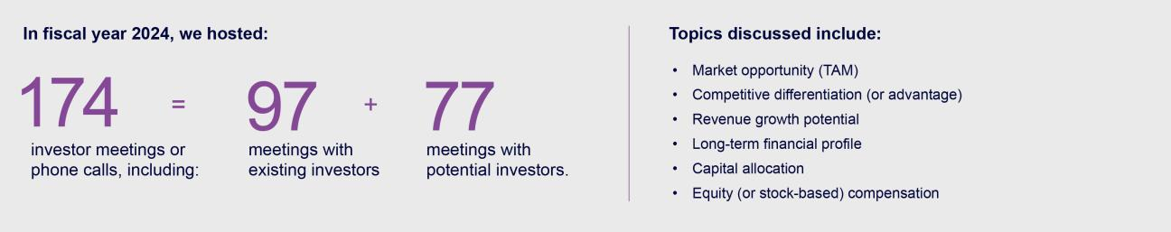

We maintain a quarterly stockholder outreach program, which includes proactive CEO and CFO post-earnings calls with our top stockholders, and subsequent phone calls with all interested investors. Our CEO, CFO, Head of Investor Relations, and senior management participate in non-deal roadshows and conferences each quarter. In fiscal year 2024 we hosted 174 investor meetings or phone calls, including 97 meetings with existing investors and 77 meetings with potential investors.

We received positive stockholder feedback on our fiscal year 2023 outreach. In particular, stockholders noted the Company’s efforts on ESG disclosures.

Stockholders were also appreciative of our independent directors’ commitment to stockholder engagement and our receptivity to stockholder feedback.

How We Choose Directors

The Nominations and Governance Committee is responsible for assessing the appropriate balance of experience, skills, and characteristics required of our Board of Directors and for carrying out adequate due diligence with respect to prospective board members. Generally speaking, we believe the Board should include individuals with skills and experience in the following areas:

• HR - Workforce of the Future |  | • | Cybersecurity | • | Global/Strategy
• | Engineering and Innovation | • | Financial Expertise | • | M&A and Integrations
• | Go-to-Market | • | SaaS | • | Executive Management

The Nominations and Governance Committee will consider nominees that are recommended by current directors, management, or stockholders. Candidates recommended by stockholders will be evaluated in the same manner as candidates identified through other means.

Nominees for director are selected on the basis of diversity, depth and breadth of experience, integrity, ability to make independent analytical inquiries, understanding of our business environment, willingness to devote adequate time to Board duties, and the interplay of the candidate’s experience and skills with those of other Board members.

20 COMMVAULT SYSTEMS, INC. | 2024 PROXY STATEMENT

Table of Contents

CORPORATE GOVERNANCE | BOARD COMMITTEES

Board Committees

The Board of Directors has three standing committees and one ad hoc committee. Each committee operates under a written charter that is available on the “Investor Relations—Corporate Governance Overview” section of our website. The members of all of the committees are independent as defined in the Nasdaq listing standards.

Members:


Messrs. Sanders

(Chair),

and Moran and Mses. Bejar and Pickens

Meetings in fiscal 2024: 5

Audit Committee

The Audit Committee is responsible for:

- the appointment, compensation, and oversight of our independent auditor

- the integrity of our financial statements

- our independent auditor’s performance qualifications, and independence

- our compliance with legal and regulatory requirements and our compliance program generally

- the performance of our internal audit function and independent auditor
- related person transactions

- our cybersecurity and IT compliance programs

- whistleblower complaints (Integrity Counts) and related investigations
- our audit results

- our critical accounting policies and practices

- the adequacy of our disclosure controls and procedures

- management of significant financial risk

The Audit Committee is also responsible for ensuring Commvault’s Code of Ethics for Senior Financial Officers remains current and for approving any non-auditing services performed by our independent auditor.

The Audit Committee relies on the knowledge and expertise of our management, the internal auditors, and the independent auditor in carrying out its oversight responsibilities.

The members of the Audit Committee meet all of the heightened independence standards for audit committee membership as set forth in the Nasdaq listing standards and SEC rules. The Board of Directors has determined that Ms. Bejar and Messrs. Moran and Sanders qualify as an “audit committee financial expert” as that term is defined in SEC rules, and that each is able to read and understand fundamental financial statements.

Members:


Ms. Lee

(Chair) and Messrs. Geeslin, Sanders and Shenkman

Meetings in fiscal 2024: met 7 times and acted by unanimous written consent 13 times

Talent Management and Compensation Committee

The TMCC is responsible for overseeing Commvault’s compensation and benefit plans, including all compensation arrangements for executive officers and directors. In particular, the TMCC sets the compensation of our CEO and reviews and approves our CEO’s recommendations regarding the compensation of our other executive officers. Additionally, the TMCC oversees:

• Commvault’s diversity and inclusion programs and policies | • talent management
• workplace health and safety matters | • management of risk arising from compensation
• executive employment agreements | practices and policies

The TMCC also is responsible for approving Commvault’s Code of Ethics.

All members of the TMCC meet the heightened independence standards for compensation committee members set forth in the Nasdaq listing standards.

21 COMMVAULT SYSTEMS, INC. | 2024 PROXY STATEMENT

Table of Contents

CORPORATE GOVERNANCE | BOARD COMMITTEES

Members:


Mses. Bejar

(Chair),

Lee and Pickens, and Mr.

Sanders

Meetings in fiscal 2024: 4


Members:

Messrs. Shenkman (Chair),

Geeslin and Moran Meetings in fiscal 2024: 4

Nominations and Governance Committee

The Nominations and Governance Committee is responsible for identifying and recommending to our Board of Directors appropriate director nominee candidates and providing oversight with respect to corporate governance matters, including reviewing our corporate governance program and approving Corporate Governance Guidelines and other governance policies. The Nominations and Governance Committee also oversees:

- Commvault’s sustainability, stewardship, and corporate social responsibility

- succession planning

- annual review of all Board committee charters

- annual performance evaluations of the CEO, Board and its committees

- recommendations for directors to serve on Board committees

Operating Committee

The general purpose of the Operating Committee is to provide oversight of various matters as determined by the Board and management. The Operating Committee reviews Commvault’s annual budget and works with management to establish margin targets and a balanced capital allocation policy. The Operating Committee also oversees earnings announcements and guidance. The focus of the Operating Committee is on achieving profitable growth, return on investment, and stockholder value.

Meetings of the Board

During the fiscal year ended March 31, 2024, our Board of Directors held four meetings, made up of both virtual and in person meetings. All of our directors attended more than 90% of the meetings of the Board of Directors and meetings of the committees of the Board on which they served during the time they served.

The Board of Directors meets in executive session, without management, at every Board meeting. During fiscal year 2024, Mr. Adamo, as the independent Chair of the Board, led these executive sessions and acted as primary spokesperson in communicating matters arising out of these sessions to management.

Because we do not regularly schedule a Board of Directors meeting to coincide with our Annual Meeting, director attendance at our Annual Meeting is encouraged but not required. All of our directors attended our 2023 Annual Meeting virtually.

How to Contact Our Board

Stockholders can contact our Board of Directors to provide comments, to report concerns, or to ask a question, at the following address:

Corporate Secretary

Commvault Systems, Inc.

1 Commvault Way

Tinton Falls, New Jersey 07724

Email: CorporateSecretary@commvault.com

Communications are distributed to our Board of Directors, or to individual directors as appropriate, depending on the nature of the communication. You may also communicate online with our Board of Directors as a group through the Investor Relations section of our website at www.commvault.com. All relevant communications directed to the full Board will be forwarded to the Chair of the Audit Committee or the Chair of the Nominations and Governance Committee, who will determine when it is appropriate to distribute such communications to other members of the Board or to management.

22 COMMVAULT SYSTEMS, INC. | 2024 PROXY STATEMENT

Table of Contents

CORPORATE GOVERNANCE | GOVERNANCE DOCUMENTS

Governance Documents

Our Code of Ethics applies to all of our directors and employees, including executives and contractors. The Code establishes our legal and ethical standards of behavior, and supports our commitments to human rights, respectful treatment, and equal opportunity, among other core values. Employees and interested third parties can report concerns or suspected violations of the Code, other company policies, or violations of the law to Commvault’s CLTO or Chief People Officer (“CPO”) directly or through Integrity Counts, an anonymous hotline at commvault@integritycounts.ca or by navigating to the website https://integritycounts.ca/org/commvault. The Code and the following additional governance documents are available in the Investor Relations section of our website under “Corporate Governance—Overview”:

• | Corporate Governance Guidelines | • | Human Rights Policy
• Amended and Restated Bylaws |  | • | Sanctions Guidelines
• Code of Ethics for Senior Financial Officers |  | • | Insider Trading Policy
• Supplier Code of Conduct |  | • Environmental, Health and Safety Policy
• | Ethics and Integrity Reporting Policy | • Board and Disclosure Committee Charters

If we were to amend or waive any provision of the Code of Ethics or Code of Ethics for Senior Financial Officers applicable to our directors and executive officers (including senior financial officers), we intend to satisfy our disclosure obligations, if any, with respect to any such waiver or amendment by posting such information on our website at the address and location specified above.

The Company has adopted and maintains insider trading policies and procedures governing the purchase, sale, and disposition of its securities by its officers, directors, and employees that are designed to promote compliance with insider trading laws, rules and regulations and applicable listing standards.

Transactions With Related Persons

The Board of Directors recognizes that transactions between the Company and certain related persons present a heightened risk of conflicts of interest. It is our policy to have the Audit Committee review and approve, ratify, or disapprove of proposed transactions or courses of dealings with respect to which executive officers or directors or members of their immediate families have an interest. The Audit Committee reviews any such transaction based upon the applicable SEC rules and our ethics and governance guidelines.

Mr. Renzo Di Blasio, the brother of Mr. Riccardo Di Blasio, our former Chief Revenue Officer, currently serves as our Senior Director of Field Operations, SaaS and Global Partners. Mr. Di Blasio has been employed by us since fiscal year 2021. Mr. Renzo Di Blasio was not employed in the same department as Mr. Riccardo Di Blasio, and his compensation is set and reviewed solely by Human Resources based on compensation studies. We did not enter into any other related person transactions during the fiscal year ended March 31, 2024.

23 COMMVAULT SYSTEMS, INC. | 2024 PROXY STATEMENT

Table of Contents

CORPORATE GOVERNANCE | DIRECTOR COMPENSATION

Director Compensation

ANNUAL CASH AND EQUITY RETAINERS

Our TMCC determines the amount and form of any fees and expense reimbursements that non-employee directors receive for or in connection with their service on Commvault’s Board of Directors. In June 2023, the TMCC engaged an external third-party compensation consultant, Compensia, to provide an assessment of our non-employee director compensation practices, including a peer analysis of practices related to cash compensation, equity compensation, and equity vesting.

For more information about our peer group, see “Compensation Discussion and Analysis—How Compensation Decisions are Made—Role of the Peer Group.”

Compensation earned by our non-employee directors for their service as members of the Board of Directors or any committee of the Board was as follows:

Who receives | Amount | Form
Every non-employee director | $42,000 | Cash annual retainer
Independent Board Chair | $110,000 | Additional cash annual retainer
Audit Committee Chair | $30,000 | Additional cash annual retainer
TMCC Committee Chair | $20,000 | Additional cash annual retainer
Chairs of the Nominations and Governance Committee and | $12,000 | Additional cash annual retainer
the Operating Committee | $12,000 | Additional cash annual retainer
Audit Committee members | $15,000 | Additional cash annual retainer
TMCC Committee members | $10,000 | Additional cash annual retainer
Members of the Nominations and Governance Committee and | $5,000 | Additional cash annual retainer
the Operating Committee | $5,000 | Additional cash annual retainer

In addition, every non-employee director received an equity retainer at a target value of $215,000 granted on August 29, 2023 in the form of 3,137 restricted stock units (“RSUs”) that will vest on the later of the one year anniversary of the grant date or the next annual meeting following the grant date, if the director is still serving on our Board at the time.

RSUs granted to the non-employee directors are issued under our 2016 Incentive Plan. See “Long-Term Equity Incentive Awards” in the Compensation Discussion and Analysis section for more information about this plan. We also reimburse our non-employee directors for their reasonable expenses incurred in attending meetings of our Board or Board committees.

24 COMMVAULT SYSTEMS, INC. | 2024 PROXY STATEMENT

Table of Contents

CORPORATE GOVERNANCE | DIRECTOR COMPENSATION

The following table shows the specific compensation received for services rendered to us by our non-employee directors in fiscal 2024. Mr. Mirchandani does not receive any additional compensation for his service on the Board.
 | Fees Earned or
Name | Paid in Cash | Stock Awards(1) | Total
Nicholas Adamo(2) | $152,000 | $214,947 | $366,947
Martha H. Bejar(3) | $64,000 | $214,947 | $278,947
R. Todd Bradley(4) | $23,332 | $— | $23,332
Keith Geeslin(5) | $60,750 | $214,947 | $275,697
Vivie “YY” Lee(6) | $64,500 | $214,947 | $279,447
Charles E. Moran(7) | $62,000 | $214,947 | $276,947
Allison Pickens(8) | $58,250 | $214,947 | $273,197
Shane Sanders(9) | $79,500 | $214,947 | $294,447
Arlen Shenkman(10) | $66,500 | $214,947 | $281,447
David F. Walker(11) | $29,473 | $— | $29,473

- The amounts in this column represent the grant date fair value of restricted stock unit awards granted during the fiscal year indicated as computed in accordance with FASB ASC Topic 718. The amounts reported disregard estimated forfeitures related to service-based vesting conditions. See the notes to our consolidated financial statements contained in our Annual Report on Form 10-K for the fiscal year ended March 31, 2024, for a discussion of all assumptions made by us in determining the grant date fair value of such awards.

- Mr. Adamo has 3,137 restricted stock units outstanding as of March 31, 2024.

- Ms. Bejar has 3,137 restricted stock units outstanding as of March 31, 2024.

- Mr. Bradley retired from the Board of Directors and subcommittees on which he served effective August 28, 2023. He received prorated cash payments for his service while serving during fiscal year 2024. He did not receive any stock awards and he had no restricted stock units outstanding as of March 31, 2024.

- Mr. Geeslin has 5,000 stock options, each of which is vested and exercisable, and 3,137 restricted stock units, in either case, outstanding as of March 31, 2024.

- Ms. Lee has 3,137 restricted stock units outstanding as of March 31, 2024.

- Mr. Moran has 3,137 restricted stock units outstanding as of March 31, 2024.

- Ms. Pickens has 3,137 restricted stock units outstanding as of March 31, 2024.

- Mr. Sanders has 3,137 restricted stock units outstanding as of March 31, 2024.

- Mr. Shenkman has 3,137 restricted stock units outstanding as of March 31, 2024.

- Mr. Walker retired from the Board of Directors and subcommittees on which he served effective August 28, 2023. He received prorated cash payments for his service while serving during fiscal year 2024. He did not receive any stock awards and he had no restricted stock units outstanding as of March 31, 2024.

Stock Ownership Guidelines for Independent Directors

We currently require our independent directors to acquire an equity ownership interest in Commvault common stock that is equal to five times their base annual cash retainer by the fifth anniversary of the date they first became a director. The TMCC is satisfied that this level of equity ownership among our independent directors is sufficient to provide motivation and to align the directors’ interests with those of our stockholders. Each independent director who is required to be in compliance with these guidelines owns the requisite amount of stock.

25 COMMVAULT SYSTEMS, INC. | 2024 PROXY STATEMENT

Table of Contents

CORPORATE GOVERNANCE | SECURITY OWNERSHIP OF MANAGEMENT AND CERTAIN BENEFICIAL OWNERS

Security Ownership of Management and Certain Beneficial Owners

MANAGEMENT

The following table shows, as of May 31, 2024, the number of shares of our common stock (the only class of voting securities outstanding) beneficially owned by: (1) each current director and nominee for director; (2) each named executive officer (defined below); and (3) all directors and current executive officers as a group. The number of shares of our common stock beneficially owned by a person includes shares of common stock issuable with respect to options, restricted stock units (including performance-based stock units), and convertible securities held by the person that are exercisable, convertible, or will vest within 60 days. The percentage of our common stock beneficially owned by a person assumes the person has exercised all options, vested in all restricted stock units, and converted all convertible securities, that are exercisable, convertible, or will vest within 60 days, and that no other person exercised any of their options, vested in any of their restricted stock units, or converted any of their convertible securities. Except as otherwise noted, each individual exercises sole voting power and investment power over the shares of voting securities shown.

 | Shares of Common | Percent of
 | Shares of Common | Common Stock
 | Stock Owned | Outstanding
Directors
Nicholas Adamo | 14,805 | *
Martha H. Bejar | 1,180 | *
Keith Geeslin(1) | 57,644 | *
Vivie “YY” Lee | 10,452 | *
Sanjay Mirchandani | 224,825 | *
Charles E. Moran | 7,830 | *
Allison Pickens | 3,696 | *
Shane Sanders | 2,167 | *
Arlen Shenkman | 10,953 | *
Named Executive Officers that are not Directors
Gary Merrill | 27,599 | *
Riccardo Di Blasio(2) | — | —
All directors and executive officers as a group (11 individuals) | 361,151 | 1%

- Less than 1%

- Includes options to acquire 5,000 shares of common stock that are exercisable within 60 days of May 31, 2024.

- Mr. Di Blasio resigned as Chief Revenue Officer (“CRO”) effective January 12, 2024. He did not own any shares of common stock as of May 31, 2024.

CERTAIN OTHER STOCKHOLDERS

The following table sets forth, as of May 31, 2024 (except to the extent otherwise indicated), certain information regarding the persons known by us to be the beneficial owner of more than 5% of our outstanding common stock. Except as otherwise noted, each entity exercises sole voting power and investment power over the shares of voting securities shown.

Name and Address of Beneficial Owner | Shares of Common | Percent of Common
Name and Address of Beneficial Owner | Stock Owned | Stock Outstanding
BlackRock, Inc.(1) | 6,195,065 | 14.1%
50 Hudson Yards | 6,195,065 | 14.1%
New York, NY 10001
Vanguard Group, Inc.(2) | 5,488,370 | 12.5%
100 Vanguard Blvd. | 5,488,370 | 12.5%
Malvern, PA 19355

- Based solely on a Schedule 13G/A filed on January 23, 2024, by BlackRock, Inc., except for Percent of Common Stock Outstanding. BlackRock, Inc. reported it held 6,104,166 shares with sole voting power, 0 shares with shared voting power, 6,195,065 shares with sole dispositive power, and 0 shares with shared dispositive power.

- Based solely on a Schedule 13G/A filed on February 13, 2024, by Vanguard Group, Inc., except for Percent of Common Stock Outstanding. The Vanguard Group, Inc. reported it held 0 shares with sole voting power, 77,230 shares with shared voting power, 5,365,649 shares with sole dispositive power and 122,721 shares with shared dispositive power.

26 COMMVAULT SYSTEMS, INC. | 2024 PROXY STATEMENT

Table of Contents

CORPORATE GOVERNANCE | FISCAL 2024 EQUITY COMPENSATION PLAN INFORMATION

Fiscal 2024 Equity Compensation Plan Information

The following table provides information as of March 31, 2024 with respect to the shares of our Common Stock that may be issuable upon the exercise of options, warrants and rights.

 |  | Weighted-Average | Number of Securities
 | Number of Securities to be | Weighted-Average | that Remained Available for
 | Number of Securities to be | Exercise Price of | Future Issuance Under Equity
 | Issued Upon Exercise of | Outstanding | Plans (Excluding
Plan Category | Outstanding Options, | Options, Warrants | Securities Reflected in
Plan Category | Warrants and Rights (a) | and Rights (b)(2) | Column (a)(c))

Equity compensation plans approved by security holders(1)

Equity compensation plans not approved by security holders

Totals

2,541,439 | $45.25 | 3,926,583
— | — | —
2,541,439 | $45.25 | 3,926,583

- Consists of shares of common stock to be issued upon exercise of outstanding options and vesting of restricted stock units ("RSUs"), including performance stock award units ("PSUs"), under our 2016 Incentive Plan. These amounts do not include potentially issuable shares under the Employee Stock Purchase Plan (the "ESPP"). We have reserved approximately 73,000 shares for the future issuance of shares under the ESPP. See "Note 10. Stock Plans" in Item 8 of our Annual Report filed on Form 10-K for the year ended March 31, 2024 for additional information.

- The weighted-average exercise price does not consider the shares issuable upon vesting of outstanding RSUs and PSUs, which have no exercise price.

27 COMMVAULT SYSTEMS, INC. | 2024 PROXY STATEMENT

Table of Contents


What am I voting on?

We are asking stockholders to approve, on a non-binding advisory basis, the compensation of our named executive officers.

Vote Recommendation


FOR the resolution approving our
executive compensation program.

Every year we give stockholders the opportunity to approve, on a non-binding, advisory basis, the compensation of our named executive officers as set forth in the following “Compensation Discussion and Analysis.”

Our executive compensation program is designed to attract, motivate, and reward talented executives who possess the skills required to formulate and drive our Company’s strategic direction and operational execution to create stockholder value. Our compensation practices, which balance long-term and short-term awards, are structured to competitively pay for performance, to encourage decision-making aligned with the Company’s long-term interests, and to promote and support our business. We encourage you to read the Compensation Discussion and Analysis for complete details about our executive compensation program, including information about the fiscal year 2024 compensation of our named executive officers.

We are asking stockholders to indicate their support for our named executive officer compensation as described in this proxy statement. This proposal, commonly known as “say-on-pay,” is not intended to address any specific item of compensation, but rather the overall executive compensation program and the related philosophy, policies, and practices. We encourage you to vote FOR the following resolution:

“RESOLVED, that the compensation paid to Commvault’s named executive officers, as disclosed pursuant to the compensation disclosure rules of the Securities and Exchange Commission, including the Compensation Discussion and Analysis, compensation tables, and any related material disclosed in Commvault’s proxy statement, is hereby APPROVED.”

The say-on-pay vote is advisory, and therefore not binding on our Company, the TMCC, or the Board of Directors. However, the Board of Directors and the TMCC value the opinions of our stockholders. If the voting results indicate there is any significant concern about our executive officer compensation program, we will consider those concerns and evaluate whether any actions are necessary to address them.

Because this is a non-binding, advisory vote, there is no specific approval requirement. However, the Board of Directors will consider that the stockholders have approved executive compensation on an advisory basis if this proposal receives the affirmative vote of a majority of the votes cast (in person or by proxy).

The Board of Directors recommends that you vote FOR the approval of Commvault’s executive compensation.

28 COMMVAULT SYSTEMS, INC. | 2024 PROXY STATEMENT

Table of Contents


Compensation Discussion and Analysis

This section discusses the compensation of the following individuals, who served as executive officers during the fiscal year ended on March 31, 2024 (the “named executive officers”).
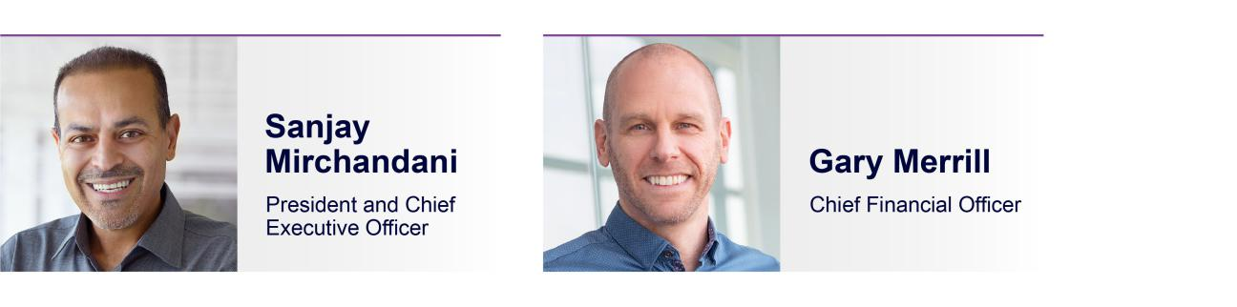

Riccardo Di Blasio, who served as our Chief Revenue Officer and is a named executive officer for our fiscal year ended March 31, 2024, resigned effective January 12, 2024. On May 15, 2024, we announced that Gary Merrill, our Chief Financial Officer during the fiscal year ended March 31, 2024, will take on the role of Chief Commercial Officer. Mr. Merrill will remain Chief Financial Officer until a successor is hired.

Table of Contents

Compensation Discussion and Analysis |  |  |  |  |  |  |  |  |  |  |  |  |  |  | 29
Executive Summary |  |  |  |  |  |  |  |  |  |  |  |  |  |  | 30
Compensation Tables |  |  |  |  |  |  |  |  |  |  |  |  |  |  | 41
 | Fiscal 2024 Summary Compensation Table |  |  |  |  |  |  |  |  |  |  |  |  |  | 41
 | Fiscal 2024 |  | Grants of Plan-Based Awards Table |  |  |  |  |  |  |  |  |  |  |  | 42
 | Fiscal 2024 |  | Outstanding Equity Awards at Fiscal Year End Table |  |  |  |  |  |  |  |  |  |  |  | 43
 | Fiscal 2024 |  | Stock Vested Table |  |  |  |  |  |  |  |  |  |  |  | 44
Pension Benefits and Deferred Compensation |  |  |  |  |  |  |  |  |  |  |  |  |  |  | 44
Individual Agreements |  |  |  |  |  |  |  |  |  |  |  |  |  |  | 44
Change in Control Agreements |  |  |  |  |  |  |  |  |  |  |  |  |  |  | 45
Estimated Payments and Benefits upon Termination or Change in Control |  |  |  |  |  |  |  |  |  |  |  |  |  |  | 46
CEO Pay Ratio |  |  |  |  |  |  |  |  |  |  |  |  |  |  | 47
Pay versus Performance |  |  |  |  |  |  |  |  |  |  |  |  |  |  | 48

29 COMMVAULT SYSTEMS, INC. | 2024 PROXY STATEMENT

Table of Contents

CD&A | EXECUTIVE SUMMARY

Executive Summary

We believe the skill, talent, judgment, and dedication of our executive officers are critical to Commvault’s long-term value. Therefore, our objective in setting compensation policies for our named executive officers is to align pay with performance, while at the same time providing fair, reasonable, and competitive compensation that will allow us to attract, retain, and reward superior executive talent. The TMCC strongly believes that executive compensation should align our executive officers’ interests with those of our stockholders by rewarding achievement of specific annual, long-term, and strategic company goals, with the ultimate objective of enhancing long-term stockholder value.

FISCAL 2024 COMPENSATION HIGHLIGHTS

Our fiscal 2024 compensation plans and payouts for our named executive officers reflects our overarching philosophy of pay-for-performance. Highlights of our executive compensation program include:

- Competitive Base Salary: Base salaries are set to be competitive within our industry and are important in attracting and retaining talented executives.

- Challenging Annual Incentive: In fiscal 2024, our Talent Management and Compensation Committee approved target annual incentives based on achievement of annual revenue and non-GAAP EBIT goals for Messrs. Mirchandani and Merrill. Based on our performance during the year, our named executive officers other than Mr. Di Blasio, earned annual incentives equal to 109% of their target for the year. Mr. Di Blasio’s bonus was paid quarterly, based upon quarterly revenue targets and results. He received 88.2% of his target award for the year. Mr. Di Blasio resigned effective January 12, 2024, and therefore only received quarterly incentive payments for the first three quarters of fiscal 2024.

- Long-term Incentive Awards: We believe that stock awards with multi-year vesting are an effective tool for motivating our named executive officers to drive long-term stockholder value. During fiscal 2024, 50% of the target value of equity granted to our named executive officers was awarded in the form of performance-based equity. These grants included a mix of PSUs tied to one, two and three-year goals as well as relative and absolute performance measurement.

Compensation Philosophy and Objectives

As a technology company, we operate in an extremely competitive and rapidly changing industry. When setting compensation policies for our executive officers, the TMCC strives to align pay with performance; to provide fair, reasonable, and competitive compensation that will allow us to attract, retain, and reward superior executive talent; and to align our executive officers’ interests with those of our stockholders by rewarding achievement of specific annual, long-term, and strategic goals. To that end, the compensation opportunities provided to our executive officers include a mix of both cash and equity elements that reward performance as measured against pre-established goals and objectives. The specific goals that our current executive compensation program rewards are focused primarily on revenue growth and profitability, as the TMCC believes those measures are the most direct drivers of long-term stockholder value creation.

Decisions with respect to the total compensation for our executive officers are based primarily upon an assessment of each individual’s performance and potential to enhance long-term stockholder value. Often, the TMCC relies on judgment rather than rigid guidelines or formulas in determining the amount and mix of compensation for each executive officer. Factors affecting such judgment include performance compared to strategic goals established at the beginning of the fiscal year, the nature and scope of each executive’s responsibilities, and whether the executive conducts all activities in a manner consistent with our core Company values.

In addition, the TMCC seeks to ensure that we maintain sound governance and compensation policies and practices. In designing and overseeing our executive compensation program, we strive to employ best practices and regularly assess our policies and practices.

What we do

- We link pay to performance by delivering a substantial portion of total compensation for our executive officers in the form of long-term equity awards.

- Our TMCC directly engages an independent compensation consultant, Compensia, to provide analysis for the annual executive compensation review and guidance on other executive compensation matters independent of management.

What we do not do

- We do not provide guaranteed bonuses to our executive officers.

- We do not provide any excise tax reimbursement payments (including “gross-ups”) with respect to payments or benefits contingent upon a change in control of our Company.

- We do not offer pension arrangements, or non-qualified deferred compensation plans or arrangements to our executive officers, other than our 401(k) plan, which is open to all United States salaried employees.

- Our named executive officers participate in broad-based company-sponsored health and welfare benefits programs on the same basis as our other full-time, salaried employees.
- We prohibit our employees, including our named executive officers, and the members of our Board of Directors from hedging or similar transactions designed to decrease risks associated with holding our equity securities.

30 COMMVAULT SYSTEMS, INC. | 2024 PROXY STATEMENT

Table of Contents

CD&A | EXECUTIVE SUMMARY

Mix of Compensation Elements

Our fiscal 2024 executive compensation program consists of three principal elements: base salary, annual cash incentive bonuses, and long-term equity incentive awards. Consistent with our pay for performance philosophy, the majority of target total direct compensation for the named executive officers in fiscal 2024 consisted of incentive awards, particularly long-term equity incentive awards. The TMCC believes that emphasizing equity-based compensation creates a strong incentive for our executives to build sustainable long-term stockholder value.
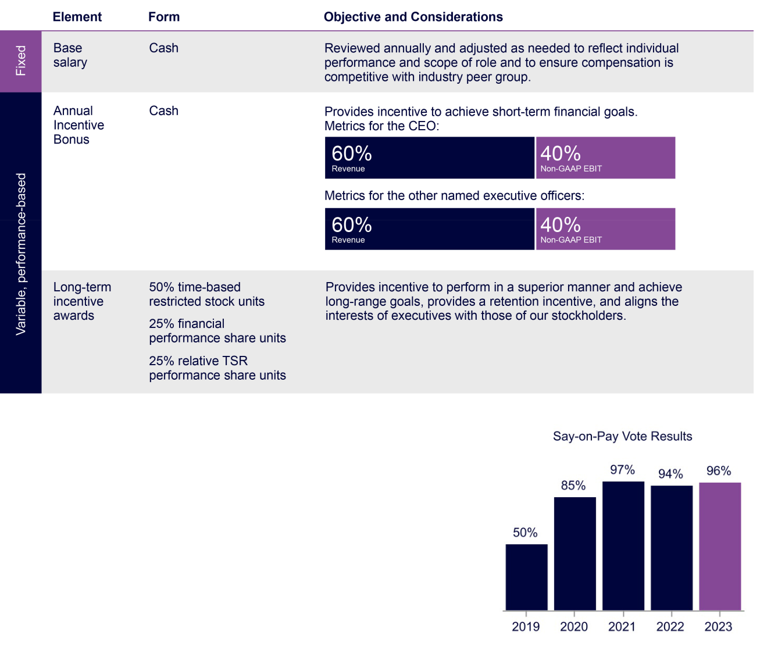

PRIOR STOCKHOLDER ADVISORY VOTE ON NAMED EXECUTIVE OFFICER COMPENSATION

In light of the 2023 say-on-pay vote, in which 96% of the votes cast were in favor of our executive compensation program, the TMCC maintained a consistent approach for fiscal year 2024. In particular, the TMCC continued to emphasize pay-for-performance through the use of performance share awards that reward our executive officers only if they deliver value for our stockholders. The TMCC will continue to consider input from our stockholders when making compensation decisions for our executive officers.

31 COMMVAULT SYSTEMS, INC. | 2024 PROXY STATEMENT

Table of Contents

CD&A | EXECUTIVE SUMMARY

How Compensation Decisions are Made

The TMCC’s goal is generally to target elements of compensation within a competitive range, using a balanced approach that does not use rigid percentiles to determine target pay levels for each compensation element. For fiscal 2024, the TMCC reviewed each element of compensation described below and set the target total direct compensation opportunities of our executive officers after taking into consideration the following factors:

- market data, including practices among companies in our compensation peer group;

- each executive officer’s scope of responsibilities;

- each executive officer’s tenure, skills, and experience;

- internal pay equity across the executive management team;

- our overall performance, taking into consideration performance versus internal plans and industry peers;

- the recommendations of our CEO; and

- general market conditions.

The TMCC does not assign relative weights or rankings to any of these factors and does not solely use any quantitative formula, target percentile or multiple for establishing compensation among the executive officers or in relation to the competitive market data.

ROLE OF TALENT MANAGEMENT AND COMPENSATION COMMITTEE

The TMCC is responsible for setting the compensation of our CEO and for reviewing and approving our CEO’s recommendations regarding the compensation of our other executive officers.

ROLE OF EXECUTIVE OFFICERS

Each year, the CEO reviews the performance and compensation of each of the executive officers and makes recommendations to the TMCC with respect to their compensation for the coming year. In addition, our CEO, CFO, and CPO support the TMCC in its work by providing information relating to our financial plans and personnel-related data.

32 COMMVAULT SYSTEMS, INC. | 2024 PROXY STATEMENT

Table of Contents

CD&A | EXECUTIVE SUMMARY

ROLE OF THE COMPENSATION CONSULTANT

The TMCC has authority under its charter to engage outside advisors and experts for advice as appropriate. In preparation for fiscal year 2024, the TMCC engaged the services of Compensia, Inc., a national compensation consulting firm, as the TMCC’s consultant to provide advice on matters relating to the compensation of our executive officers and non-employee directors. Compensia provided the TMCC with an analysis of industry sector competitive market data regarding executive compensation, information on compensation trends, and peer group and general market data, as well as assistance with the parameters used to determine the peer group, base salaries, incentive plan design, and the overall structure of our executive compensation program.

The TMCC regularly reviews the objectivity and independence of the advice provided by its compensation consultant. The TMCC has evaluated Compensia’s engagement and, based on the six factors for assessing independence and identifying potential conflicts of interest that are set forth in SEC rules and Nasdaq rules (and such other factors as were deemed relevant under the circumstances), the TMCC has determined that its relationship with Compensia and the work of Compensia on behalf of the TMCC did not raise any conflict of interest.

ROLE OF THE PEER GROUP

In preparation for fiscal 2024, the TMCC engaged Compensia to conduct a competitive market analysis for purposes of evaluating our base salaries, annual cash bonus opportunities, and long-term equity incentive plan. The data from this analysis was used to ensure that our executive compensation program was optimally structured to attract, motivate, retain, and reward our highly experienced management team, to keep management focused during our expected period of growth, and to align our compensation practices with comparable technology industry companies.

In developing the peer group, the TMCC targeted U.S.-headquartered companies within similar industries and of a similar size as the Company. In particular, the TMCC targeted direct competitors and other business application software companies. The peer companies were also evaluated based on two financial criteria:

- Revenue: Target between approximately $400 million and $1.6 billion (0.5x to 2.0x the Company’s trailing 12-month revenue); and

- Market Capitalization: Target between $1.0 billion and $9.0 billion (0.3x to 3.0x the Company’s market capitalization)

The companies included in the peer group for fiscal year 2024 were:


ACI Worldwide | MicroStrategy | Pure Storage
Alteryx | N-Able | Qualys
Blackbaud | NetScout Systems | Rapid7
Box | New Relic | Tenable Holdings
DigitalOcean Holdings | Nutanix | Varonis Systems
Informatica | Progress Software

COMMVAULT VS. PEER GROUP

The Company and the TMCC review the peer group annually and make changes as needed to ensure it remains appropriate. The competitive positioning of our trailing four-quarters of revenue and market capitalization below reflect our profile as of January 2023, when the TMCC approved the peer group for fiscal year 2024.
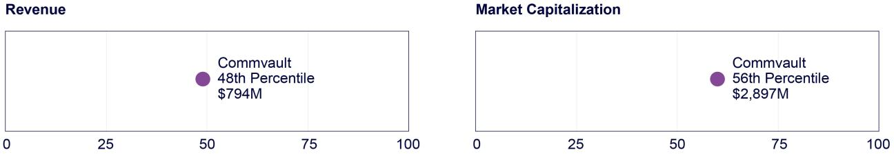

33 COMMVAULT SYSTEMS, INC. | 2024 PROXY STATEMENT

Table of Contents

CD&A | FISCAL YEAR 2024 COMPENSATION DECISIONS

Fiscal Year 2024 Compensation Decisions

BASE SALARY

The TMCC generally compares our executive officer base salaries to the 25th—75th percentile of the competitive market data in the analysis prepared by its compensation consultant.

Typically, base salary levels are reviewed annually as part of our performance review process, as well as upon a promotion or other change in job responsibility. In addition to considering the competitive market analysis when setting base salaries for fiscal 2024, the TMCC also evaluated the scope of, and accountability associated with, each executive officer’s position and the overall experience of each executive officer. The table below shows the fiscal 2024 and 2023 base salary rates for each named executive officer.

Name and Principal Position Held | Fiscal 2024 Salary | Fiscal 2023 Salary | Percentage Increase
Sanjay Mirchandani | $645,000 | $645,000 | —%
President and Chief Executive Officer | $645,000 | $645,000 | —%
Gary Merrill | $451,000 | $410,000 | 10%
Chief Financial Officer | $451,000 | $410,000 | 10%
Riccardo Di Blasio | $475,000 | $475,000 | —%
Former Chief Revenue Officer | $475,000 | $475,000 | —%

ANNUAL INCENTIVE PLAN

During fiscal 2024, Messrs. Mirchandani, Merrill, and Di Blasio each participated in the Commvault Annual Incentive Plan (the “Fiscal 2024 AIP”), which made them eligible to earn a cash bonus based on achievement of pre-established corporate financial goals.

Target Annual Cash Incentive Opportunities

The TMCC approved target cash incentive opportunities for the named executive officers in May 2023 after considering a competitive market analysis, the scope of, and accountability associated with, each executive officer’s position, the performance of each executive officer since the last annual performance review and the overall experience of each executive officer. Mr. Di Blasio was evaluated against certain quarterly (rather than annual) goals and had more upside potential for one metric (revenue), as discussed below. Mr. Di Blasio resigned effective January 12, 2024, and therefore only received quarterly incentive payments for the first three quarters of fiscal 2024.

The target cash incentive opportunities were as follows:

Executive | Fiscal 2024 Salary | Target Annual Cash Incentive | Target Annual Cash Incentive(1)
Sanjay Mirchandani | $645,000 | 100% | $645,000
Gary Merrill | $451,000 | 70% | $315,700
Riccardo Di Blasio | $475,000 | 100% | $475,000

- Cash bonus payments under the Fiscal 2024 AIP could range from zero to 200% of target.

34 COMMVAULT SYSTEMS, INC. | 2024 PROXY STATEMENT

Table of Contents

CD&A | FISCAL YEAR 2024 COMPENSATION DECISIONS

Performance Measures

In May 2023, the TMCC selected total revenue (weighted 60%) and non-GAAP EBIT (weighted 40%) as the performance metrics for the Fiscal 2024 AIP. These metrics were selected because the TMCC believes that, at this stage of our development, revenue growth and profitability are the most relevant measures of Commvault’s financial performance and the measures most closely correlated to increasing stockholder value. In fact, in the course of our regular stockholder engagements, stockholders often mention their approval of our revenue and non-GAAP EBIT performance measures. Further, in our public communications (including on earnings calls), our disclosures typically reference revenue and non-GAAP EBIT, in addition to GAAP performance metrics, as the primary means we use to evaluate our own performance. In other words, these metrics are closely tied to how we manage the business.

For purposes of the Fiscal 2024 AIP, the TMCC set the various performance levels for these performance metrics and the payout amounts for each performance level as shown below.

For Messrs. Mirchandani and Merrill

Metric | Weight | Threshold | Target | Maximum
Metric | Weight | (50% payout) | (100% payout) | (200% payout)
Revenue | 60% | 93% | 100% | 104%
Non-GAAP EBIT | 40% | 89% | 100% | 108%

If actual performance falls between the specified goals, the payout percentage is calculated on a linear basis.

The actual bonus paid to an individual named executive officer, other than our CEO, is also subject to modification based on individual performance, +/-200% of achievement.

For Mr. Di Blasio

Because Mr. Di Blasio is our Chief Revenue Officer, the TMCC believes he should have different targets and multipliers that emphasize the revenue metric. Specifically, Mr. Di Blasio had four independent quarterly revenue goals that, in the aggregate, were the same amount as the annual goal for the other named executive officers. Since Mr. Di Blasio could earn his incentive bonus incrementally—based on results for each individual quarter—and his payout percentage was potentially higher, the TMCC anticipated that the payout percentages for the revenue metric for the named executive officers might vary.

In keeping with the quarterly schedule for Mr. Di Blasio’s incentive bonus, he also earned incremental amounts for the non-GAAP EBIT metric. His goal for non-GAAP EBIT was the same as the annual goal set for the other named executive officers. However, for each of the first three quarters of the AIP performance period, Mr. Di Blasio received an amount based on an assumed achievement of 80% of target for non-GAAP EBIT. At the end of the fourth quarter the payout associated with the non-GAAP EBIT metric would have been adjusted to reflect Commvault’s actual performance for the year. However, Mr. Di Blasio resigned effective January 12, 2024, and therefore only received quarterly incentive payments for the first three quarters of fiscal 2024.

FISCAL 2024 ANNUAL CASH INCENTIVE PLAN DECISIONS

In May 2024, the TMCC determined that our achievement for the revenue and non-GAAP EBIT portions of the Fiscal 2024 AIP resulted in a payout equal to 109% of target for Messrs. Mirchandani and Merrill.

 | Achievement | Target | Achievement | Payout | Weighting | Weighted
 | (in millions) | (in millions) | vs. Target | Factor | Weighting | Payout
Annual Revenue | $839 | $843 | 99.5% | 97.1% | 60.0% | 58.4%
Non-GAAP EBIT | $177 | $174 | 102.1% | 126.3% | 40.0% | 50.6%
Total |  |  |  |  | 100.0% | 109.0%

35 COMMVAULT SYSTEMS, INC. | 2024 PROXY STATEMENT

Table of Contents

CD&A | FISCAL YEAR 2024 COMPENSATION DECISIONS

No individual performance multiplier was applied to the earned bonus for our named executive officers. As a result, the named executive officers received the annual incentive bonuses shown below.

 | Target Annual Cash | Percentage of Target | Actual Annual
 | Incentive Opportunity | Annual Incentive Earned | Incentive Earned
Sanjay Mirchandani | $645,000 | 109.0% | $703,050
Gary Merrill | $315,700 | 109.0% | $344,113
Riccardo Di Blasio(1) | $475,000 | 88.2% | $314,280

- Mr. Di Blasio resigned as CRO effective January 12, 2024, and therefore did not receive his fourth quarter bonus payment, impacting his overall incentive earned.

LONG-TERM EQUITY INCENTIVE AWARDS

We provide long-term equity incentive awards pursuant to our 2016 Incentive Plan, which is designed to provide plan participants with appropriate incentives to achieve long-range goals and to align participants’ interests with those of our stockholders. The 2016 Incentive Plan permits the grant of stock options, stock appreciation rights, restricted stock awards, performance stock awards, and other forms of equity based on, or related to, shares of our common stock, and cash incentive awards that are contingent on performance.

Generally, new executive officers receive a significant equity award when they commence employment. The size of each equity award is set at a level that we believe is appropriate to create a meaningful opportunity for stock ownership based upon our equity award grant guidelines, the individual’s position with Commvault, and the individual’s potential for future responsibility and promotion. The relative weight given to each of these factors varies from individual to individual. All equity awards granted to our executive officers are approved by the TMCC.

When annual equity awards are granted, typically in May of each year, the TMCC bases grants on an evaluation of each executive officer’s performance during the prior fiscal year, as well as our overall corporate financial performance. The terms of annual awards and the number and form of awards granted are designed to ensure the recipient has a meaningful incentive to remain a Commvault employee.

In preparation for granting annual equity awards in May 2023, the TMCC reviewed a competitive market analysis prepared by Compensia to obtain data primarily related to the grant date fair value of the equity awards granted to similarly situated executives at companies in our compensation peer group. The awards granted to our named executive officers in May 2023 were provided in three forms, and subject to the terms and conditions shown below.

Time-Based RSU awards | These awards vest 33.3% on the first anniversary of the grant date and an additional 8.375% quarterly
50% | thereafter until fully vested, generally subject to continued employment on the vesting date.
Relative TSR PSU awards | Recipients may earn up to 200% of their target award based on Commvault’s TSR performance relative to
25% | the components of the Russell 3000 Index over equally weighted one, two, and three-year performance
 | periods. Earned shares, if any, vest at the end of each applicable annual performance period.
Financial PSU awards | Recipients may earn up to 200% of their target award based 100% on Commvault’s total annualized
25% | recurring revenue (“ARR”) for fiscal 2024. Earned shares, if any, vest 33.3% on the first anniversary of the
 | grant date and an additional 8.375% quarterly thereafter until fully vested, generally subject to continued
 | employment on the vesting date.

Based on the competitive market analysis prepared by Compensia, Commvault’s long-term equity grants are more heavily weighted toward performance-based awards than is the norm within our compensation peer group.

36 COMMVAULT SYSTEMS, INC. | 2024 PROXY STATEMENT

Table of Contents

CD&A | FISCAL YEAR 2024 COMPENSATION DECISIONS

Taking into consideration market data and the performance of individual executive officers, the TMCC approved the following equity award grants for our named executive officers:
Executive | Aggregate | Time-based restricted | Relative TSR | Financial PSU
Executive | target value | stock unit awards (#) | PSU awards (#) | awards (#)
Sanjay Mirchandani | $9.7 million | 77,811 | 38,905 | 38,905
Gary Merrill | $3.2 million | 25,669 | 12,834 | 12,834
Riccardo Di Blasio | $2.5 million | 20,054 | 10,027 | 10,027

In determining the number of shares granted to each named executive officer, the TMCC converted the target value of each award to a number of units based on the 5-trading day average closing price of our common stock prior to the grant date.

Relative TSR PSU Awards

The Relative TSR PSU awards granted to our named executive officers in fiscal 2024 will be earned (or not) based on our TSR measured relative to the components of the Russell 3000 Index over three equally weighted overlapping one-year, two-year, and three-year performance periods. The payout opportunities for the Relative TSR PSU awards are as follows:

Relative TSR Percentile Rank | % of Target PSU Earned
< 25th | 0%
25th | 50%
₅₀th | 100%
75th | 150%
85th | 200% (max)

Scale is linear between shown points.

Regardless of Commvault’s relative TSR performance, earned shares cannot exceed 100% of target if the Company’s stock price is lower at the end of the performance period than it was at the beginning.

The TMCC regularly considers the appropriate time horizon for the performance measures used in the compensation plan for our named executive officers. The TMCC believes that using multiple-year vesting for the Relative TSR PSUs appropriately balances the one-year performance period for the annual bonus and the three-year vesting period for the time-based RSUs and Financial PSUs.

Relative TSR PSU Awards - Performance Vesting

Grant | May | May | May | May | May
Grant | 2019 | 2020 | 2021 | 2022 | 2023
Actual Vest %:
First annual tranche | 96% | 105% | 98% | 100% | 200%
Second annual tranche | 95% | 101% | 100% | 200% | TBD
Third annual tranche | 87% | 117% | 194% | TBD | TBD

Earned units for each performance period, if any, will vest following certification of our results by the TMCC.

For the one-year performance period of the May 2023 award that ended May 15, 2024, our total stockholder return of 71.01% was positioned at the 90th percentile of the benchmark. As a result, the TMCC certified a payout equal to 200% of target for the portion of the Relative TSR PSU awards related to the first annual tranche.

For the two-year performance period of the May 2022 award that ended May 16, 2024, our total stockholder return of 68.89% was positioned at the 87th percentile of the benchmark. As a result, the TMCC certified a payout equal to 200% of target for the portion of the Relative TSR PSU awards related to the second annual tranche.

For the three-year performance period of the May 2021 award that ended May 17, 2024, our total stockholder return of 51.98% was positioned at the 84th percentile of the benchmark. As a result, the TMCC certified a payout equal to 194% of target for the portion of the Relative TSR PSU awards related to the third annual tranche.

37 COMMVAULT SYSTEMS, INC. | 2024 PROXY STATEMENT

Table of Contents

CD&A | FISCAL YEAR 2024 COMPENSATION DECISIONS

Financial PSU awards

The Financial PSUs granted to our named executive officers in fiscal 2024 were eligible to be earned based on our level of achievement against total annualized recurring revenue (“ARR”) goals established at the beginning of fiscal 2024 and measured over a one-year performance period.
Achievement | ARR Achievement | ARR Achievement | % of Target PSU Earned
Achievement | ARR Achievement | (% of Target) | % of Target PSU Earned
Below Threshold | < $668 million | <88% | —%
Threshold | $668 million | 88% | 50%
Target | $760 million | 100% | 100%

In the event that our actual performance exceeds target, the payout expressed as a percent of target will increase by 6% of each 1% of incremental ARR performance above target up to a maximum payout equal to 200%.

Our actual ARR achievement for fiscal 2024 was equal to 101.3% of target. As a result, the TMCC certified a payout equal to 108% of the target number of shares. Any shares earned based on our actual one-year financial performance were to vest 33.3% on the first anniversary of the grant date and an additional 8.375% quarterly thereafter until fully vested.

OTHER BENEFITS

Our executive officers participate in retirement, health and welfare benefit programs that are substantially the same as the benefits for all other eligible Commvault employees. These benefits include a 50% matching contribution on the first 4% of eligible pay contributed to our 401(k) plan.

Our executive officers also are eligible to participate in our Employee Stock Purchase Plan (the “ESPP”). The ESPP is a stockholder approved plan under which substantially all employees may purchase the Company’s common stock through payroll deductions at a price equal to 85% of the lower of the fair market value of the common stock as of the beginning or the end of six-month offering periods. An employee’s payroll deductions under the ESPP are limited to 10% of salary, and employees may not purchase more than $25,000 of common stock during any calendar year. Messrs. Mirchandani, Merrill and Di Blasio participated in the ESPP in fiscal 2024 and received nominal benefits related to the 15% discount on the purchase price of the Company’s common stock.

Our executive officers are generally not provided any perquisite or other benefits not available to our other employees. As disclosed in the Summary Compensation Table below, we do provide our Chief Executive Officer with a car service in connection with business travel. In addition, Mr. Mirchandani and Mr. Merrill are provided access to financial and estate planning support.

COMPENSATION RISK ASSESSMENT

We have reviewed our compensation policies and practices for all employees and concluded that any risks arising from our policies and practices are not reasonably likely to have a material adverse effect on us.

INDIVIDUAL AGREEMENTS

We have entered into individual agreements with each of our named executive officers. Mr. Mirchandani has entered into an employment agreement with the Company, and all other named executive officers have entered into executive retention and severance agreements. We entered into these arrangements to acknowledge each executive’s importance to Commvault and our stockholders and to attempt to avoid the distraction and loss of key management personnel that may occur in connection with rumored or actual fundamental corporate organizational changes. As more fully described in the section entitled “Individual Agreements”, these agreements entitle a named executive officer to payments and benefits if employment is terminated by the Company without “cause,” or by him with “good reason,” within the two-year period following a change in control of the Company.

STOCK OWNERSHIP GUIDELINES FOR THE CEO

We currently require our CEO to acquire an equity ownership interest in Commvault common stock that is equal to five times his current annual base salary, to align his interests with those of our stockholders. As of March 31, 2024, Mr. Mirchandani’s equity ownership exceeded this required level of ownership.

38 COMMVAULT SYSTEMS, INC. | 2024 PROXY STATEMENT

Table of Contents

CD&A | FISCAL YEAR 2024 COMPENSATION DECISIONS

HEDGING PROHIBITION

We have a policy that prohibits our employees (including officers) and directors from engaging in any hedging transactions with regard to Commvault common stock, including: short sales; purchases or sales of puts, calls, or other derivative securities; and purchases of financial instruments (such as prepaid variable forward contracts, equity swaps, collars, and exchange funds) or other transactions that hedge or offset, or are designed to hedge or offset, any decrease in the market value of Commvault securities. Hedging transactions enable the holder to continue to own shares of our common stock, but without the full risks and rewards of ownership. The Board believes these transactions are inadvisable because a holder who no longer has the full risks and rewards of ownership may not have the same objectives as the Company and our other stockholders.

PLEDGING PROHIBITION

We have a policy that prohibits our employees (including officers) and directors from pledging Commvault securities as collateral to secure a personal loan. The Board believes these transactions are inadvisable because the practice may put the stock price at risk due to an employee’s personal decision and create misalignment of employee interests.

CLAWBACK POLICY

We have a “clawback” policy that permits the TMCC to seek to recover cash or equity incentive awards from certain senior leaders, in the event Commvault is required to prepare a financial restatement, without regard to whether the restatement is caused by wrongdoing, negligence, or misconduct. In October 2023 we adopted an additional Clawback Policy for executive officers that complies with the SEC rules promulgated under the Dodd-Frank Act and the Nasdaq listing standards. This policy applies to all incentive-based compensation (including cash bonus payments) received by our current and former Section 16 officers on or after October 2, 2023, the effective date specified in the Nasdaq listing standards. Under this policy, “Incentive-based compensation” means any compensation that is granted, earned, or vested based wholly or in part upon the attainment of a financial reporting measure. In the event of an accounting restatement that impacts the financial reporting measures on which incentive-based compensation is calculated, this policy will require the clawback of the amount by which the compensation actually received exceeds the amount that otherwise would have been received based on the restated financial results.

TAX AND ACCOUNTING CONSIDERATIONS

Section 162(m) of the Internal Revenue Code places a limit of $1 million on the amount of compensation that we may deduct as a business expense in any year with respect to certain of our most highly paid executive officers. While the TMCC considers the deductibility of compensation as one factor in determining executive compensation, the TMCC believes it is in the best interests of our stockholders to maintain flexibility in our approach to executive compensation and to structure a program that we consider to be the most effective in attracting, motivating, and retaining key executives.

We account for the equity awards granted to all of our employees under ASC 718, Compensation—Stock Compensation, which requires us to estimate and record compensation expense over the service period of the award. All equity awards to our employees, including our executive officers, and to the non-employee members of our Board of Directors, are reflected in our consolidated financial statements, based upon the applicable accounting guidance, at fair value on the grant date.

39 COMMVAULT SYSTEMS, INC. | 2024 PROXY STATEMENT

Table of Contents


The Talent Management and Compensation Committee has reviewed and discussed with management the disclosures contained in the foregoing “Compensation Discussion and Analysis.” Based on this review and discussion, the Talent Management and Compensation Committee recommended to the Board that the section entitled “Compensation Discussion and Analysis” be included in this Proxy Statement for the Annual Meeting.

Members of the Talent Management and Compensation Committee

Vivie “YY” Lee—Chair

Keith Geeslin

Shane Sanders

Arlen Shenkman

40 COMMVAULT SYSTEMS, INC. | 2024 PROXY STATEMENT

Table of Contents


Fiscal 2024 Summary Compensation Table

The following table summarizes the compensation earned by the named executive officers during the fiscal years ended March 31, 2024, 2023, and 2022.

 |  |  |  | Stock | Non-Equity | All Other
 |  |  |  | Stock | Incentive Plan | All Other
Name and Principal Position | Year | Salary ($) | Bonus ($) | Awards | Compensation | Compensation | Total ($)
 |  |  |  | ($)(1) | ($)(2) | ($) | Total ($)
Sanjay Mirchandani | 2024 | 645,000 | — | 10,694,658 | 703,050 | 65,052(4) | 12,107,760
President and Chief Executive Officer | 2023 | 645,000 | — | 9,722,388 | 462,465 | 22,950 | 10,852,803
 | 2022 | 634,038 | — | 9,413,382 | 652,224 | 60,568 | 10,760,212
Gary Merrill(3) | 2024 | 451,000 | — | 3,528,001 | 344,113 | 20,455(5) | 4,343,569
Chief Financial Officer | 2023 | 408,846 | — | 1,890,383 | 176,382 | 6,146 | 2,481,757
Riccardo Di Blasio | 2024 | 383,654 | — | 2,756,322 | 314,280 | 5,081(6) | 3,459,337
Former Chief Revenue Officer | 2023 | 472,115 | — | 3,024,622 | 356,250 | 5,812 | 3,858,799
 | 2022 | 449,423 | — | 2,768,656 | 577,539 | 8,185 | 3,803,803

- The amounts reported in this column represent the grant date fair value of the restricted stock unit awards and performance stock unit awards granted during the fiscal year indicated as computed in accordance with FASB ASC Topic 718. The amounts shown disregard estimated forfeitures related to service-based vesting conditions and assume performance stock units at target (100%). If the performance stock unit awards are achieved at the maximum (200%), this would result in stock award values of $16,539,356 (for Mr. Mirchandani), $5,456,052 (for Mr. Merrill), and $4,262,678 (for Mr. Di Blasio). See our consolidated financial statements contained in our Annual Report on Form 10-K for the year ended March 31, 2024, for a discussion of the assumptions we made in determining the grant date fair value of such awards.

- The amounts reported in this column consist of annual cash incentive bonuses earned during the fiscal year indicated and are more fully described in section “Fiscal 2024 Compensation Decisions” under the heading “Annual Incentive Plan” in the Compensation Discussion and Analysis.

- Mr. Merrill became a named executive officer effective July 1, 2022 and compensation information for fiscal 2022 has not been provided in accordance with SEC rules.

- Mr. Mirchandani’ s other annual compensation in fiscal 2024 included $6,100 related to his 401(k) plan company matching contributions, $12,000 for financial and estate planning, and $46,952 related to the use of a corporate car, which includes $13,077 related to personnel transportation service costs.

- Mr. Merrill’s other annual compensation in fiscal 2024 included $6,359 related to his 401(k) plan company matching contributions, and $14,096 for financial and estate planning.

- Mr. Di Blasio’s other annual compensation in fiscal 2024 included his 401(k) plan company matching contributions of $5,081.

41 COMMVAULT SYSTEMS, INC. | 2024 PROXY STATEMENT

Table of Contents

COMPENSATION TABLES | FISCAL 2024 GRANTS OF PLAN-BASED AWARDS TABLE

Fiscal 2024 Grants of Plan-Based Awards Table

The following table sets forth information as to grants of plan-based awards to our named executive officers in fiscal 2024:

 |  | Estimated future payouts under non-equity |  |  | Estimated future payouts under
 | Grant & | incentive plan awards ($) |  |  | equity incentive plan awards (#)
 | Approval
Name | Date | Threshold(1) | Target(2) | Maximum(3) | Threshold(4) | Target(5) | Maximum(6)

All Other
Stock
Awards: | Grant Date
Number of | Fair Value
Shares of | of Stock
Stock or | and Option
Units | Awards
(#)(7) | ($)(8)

Sanjay Mirchandani | — | 322,500 | 645,000 | 1,290,000 | — | — | — | — | —
 | 05/15/23 | — | — | — | — | — | — | 77,811 | 4,849,960
 | 05/15/23 | — | — | — | 19,452 | 38,905 | 77,810 | — | 3,419,750
 | 05/15/23 | — | — | — | 19,452 | 38,905 | 77,810 | — | 2,424,948
Gary Merrill | — | 157,850 | 315,700 | 631,400 | — | — | — | — | —
 | 05/15/23 | — | — | — | — | — | — | 25,669 | 1,599,949
 | 05/15/23 | — | — | — | 6,417 | 12,834 | 25,668 | — | 1,128,109
 | 05/15/23 | — | — | — | 6,417 | 12,834 | 25,668 | — | 799,943
Riccardo Di Blasio | — | 237,500 | 475,000 | 950,000 | — | — | — | — | —
 | 5/15/23(9) | — | — | — | — | — | — | 20,054 | 1,249,966
 | 5/15/23(9) | — | — | — | 5,013 | 10,027 | 20,054 | — | 881,373
 | 5/15/23(9) | — | — | — | 5,013 | 10,027 | 20,054 | — | 624,983

- Represents the threshold amount with respect to each applicable metric under the Fiscal 2024 AIP for each named executive officer. Actual total payouts may be less than the threshold amounts shown if threshold performance goals are not attained. See “Annual Incentive Plan” in section “Fiscal 2024 Compensation Decisions” for more information on the Fiscal 2024 AIP and performance objectives for each of our named executive officers.

- Represents the total target amount with respect to each applicable metric under the Fiscal 2024 AIP for each named executive officer. See “Annual Incentive Plan” in section “Fiscal 2024 Compensation Decisions” for more information.

- Represents the maximum amount with respect to each applicable metric under the Fiscal 2024 AIP for each named executive officer. See “Annual Incentive Plan” in section “Fiscal 2024 Compensation Decisions” for more information.

- Represents the threshold amount for performance stock units granted, or 50% of the target amount, for each named executive officer under our 2016 Incentive Plan. If the threshold conditions for these awards are not met, the award value will be zero. See “Long-Term Equity Incentive Awards” in section “Fiscal 2024 Compensation Decisions” for more information on the plan and the related performance objectives.

- Represents the target amount for performance stock units granted for each named executive officer under our 2016 Incentive Plan. See “Long-Term Equity Incentive Awards” in section “Fiscal 2024 Compensation Decisions” for more information.

- Represents the maximum amount for performance stock units granted. The maximum payout opportunity for PSUs is 200% for all of the named executive officers. See “Long-Term Equity Incentive Awards” in section “Fiscal 2024 Compensation Decisions” for more information.

- Amounts in this column reflect time-based restricted stock unit awards granted during fiscal 2024 to our named executive officers under our 2016 Incentive Plan.

- The amounts reported in this column represent the grant date fair value of the restricted stock unit awards and performance stock unit awards (shown at target) granted during the fiscal year indicated as computed in accordance with FASB ASC Topic 718. The amounts shown disregard estimated forfeitures related to service-based vesting conditions. See Note 10 of our consolidated financial statements contained in our Annual Report on Form 10-K for the year ended March 31, 2024, for a discussion of the assumptions we made in determining the grant date fair value of such awards.

- In connection with Mr. Di Blasio’s resignation effective January 12, 2024, all unvested shares as of that date were forfeited.

42 COMMVAULT SYSTEMS, INC. | 2024 PROXY STATEMENT

Table of Contents

COMPENSATION TABLES | FISCAL 2024 OUTSTANDING EQUITY AWARDS AT FISCAL YEAR END TABLE

Fiscal 2024 Outstanding Equity Awards at Fiscal Year End Table

The following table reflects all outstanding equity awards held by our named executive officers as of March 31, 2024:

 |  | Option Awards |  |  |  | Stock Awards
 |  |  |  |  |  |  | Equity Incentive | Equity Incentive
 |  | Number of |  |  |  | Market Value | Equity Incentive | Plan Awards:
 |  | Number of |  |  |  | Market Value | Plan Awards: | Market or
 |  | Securities |  |  |  | of Unearned | Number of | Payout Value of
 |  | Underlying |  |  | Number of | Shares or | Unearned | Unearned
 |  | Unexercised | Option | Option | Shares or | Units of | Shares, Units or | Shares, Units or
 |  | Options | Option | Option | Units of Stock | Stock That | Other Rights | Other Rights
 |  | (Exercisable) | Exercise | Expiration | That Have Not | Have Not | That Have Not | That Have Not
Name | Grant Date(1) | (#) | Price($) | Date | Vested(#)(2) | Vested($) | Vested(#)(3) | Vested($)
Sanjay Mirchandani | 05/15/23 | — | — | — | 119,823 | 12,153,647 | 38,905 | 3,946,134
 | 05/16/22 | — | — | — | 53,219 | 5,398,003 | 25,910 | 2,628,051
 | 05/17/21 | — | — | — | 9,347 | 948,066 | 10,660 | 1,081,244
Gary Merrill | 05/15/23 | — | — | — | 39,527 | 4,009,224 | 12,834 | 1,301,753
 | 05/16/22 | — | — | — | 10,346 | 1,049,395 | 5,038 | 511,004
 | 05/17/21 | — | — | — | 1,099 | 111,472 | 1,254 | 127,193
Riccardo Di Blasio(4) | — | — | — | — | — | — | — | —

- Unless otherwise indicated, all restricted stock unit awards granted to our named executive officers vest over three years, with 33.3% vesting on the first anniversary of the grant date and 8.375% vesting quarterly thereafter, subject, in each case, to continued employment or service through the applicable vesting date. Financial performance awards follow the same vesting schedule, but at their respective achievement rates. Relative TSR-based awards vest equally on an annual basis over three years, subject to continued employment or service through the applicable vesting date. The vesting commencement date for all restricted stock unit awards and performance stock unit awards is the grant date.

- Time-based awards include time-vesting restricted stock unit awards and financial performance stock unit awards at the rate achieved for the respective fiscal year. The May 2021 financial performance stock unit awards achieved at 150%, the May 2022 financial performance stock unit awards achieved at 128%, and the May 2023 financial performance stock unit awards achieved at 108%. The value is computed based on the number of achieved unvested shares multiplied by the closing market price of our common stock at the end of fiscal 2024. The actual value (if any) to be realized by the named executive officer depends on whether the shares vest and the future performance of our common stock. On March 31, 2024, the closing price of our common stock was $101.43 per share. See “Long-Term Equity Incentive Awards” in section “Fiscal 2024 Compensation Decisions” for more information on the plan and the related performance objectives.

- Performance-based awards include Relative TSR performance stock unit awards at the March 31, 2024 payout rate based on Commvault’s TSR measured relative to the components of the Russell 3000 Index. The May 2021, May 2022 and May 2023 awards are calculated at an estimated 100% payout (target). The value is computed based on the number of achieved unvested shares multiplied by the closing market price of our common stock at the end of fiscal 2024. The actual value (if any) to be realized by the named executive officer depends on whether the shares vest and the future performance of our common stock. On March 31, 2024, the closing price of our common stock was $101.43 per share. See “Long-Term Equity Incentive Awards” in section “Fiscal 2024 Compensation Decisions” for more information on the plan and the related performance objectives.

- In connection with Mr. Di Blasio’s resignation effective January 12, 2024, all unvested shares as of that date were forfeited.

43 COMMVAULT SYSTEMS, INC. | 2024 PROXY STATEMENT

Table of Contents

COMPENSATION TABLES | FISCAL 2024 STOCK VESTED TABLE

Fiscal 2024 Stock Vested Table

The following table sets forth information on the number and value of restricted stock units vested during fiscal 2024 for our named executive officers.

 | Stock Awards
Name | Number of Shares | Value Realized
Name | Acquired on Vesting(#) | On Vesting($)(1)
Sanjay Mirchandani | 176,615 | 12,235,135
Gary Merrill | 27,476 | 1,898,828
Riccardo Di Blasio(2) | 45,200 | 2,986,198

- The value realized on the vesting of the restricted stock unit awards and performance stock unit awards is based on the market price of our common stock on the vesting date. See “Long-Term Equity Incentive Awards” in section “Fiscal 2024 Compensation Decisions” for more information on the plan and the related performance objectives.

- In connection with Mr. Di Blasio’s resignation effective January 12, 2024, all unvested shares as of that date were forfeited.

Pension Benefits and Deferred Compensation

None of our named executive officers during fiscal 2024 participated in or had account balances in qualified or non-qualified defined benefit plans sponsored by Commvault or in non-qualified defined contribution plans maintained by Commvault.

Individual Agreements

The following table summarizes the individual agreements between Commvault and the named executive officers.

 | Sanjay Mirchandani |  | Gary Merrill |  | Riccardo Di Blasio
Compensation | • annual base salary subject to | • | annual base salary | • | annual base salary
arrangements | annual review by our Board of | • | eligible for an annual cash bonus | • | eligible to participate in a sales
 | Directors
 | Directors | • entitled to participate in the |  |  | incentive compensation plan that
 | • eligible for an annual cash bonus |  |  |  | provides a cash bonus opportunity
 | • eligible for an annual cash bonus |  | employee benefits plans in which |  | provides a cash bonus opportunity
 | • entitled to participate in the |  | our other executives may participate • |  | entitled to participate in the
 | employee benefits plans in which | • | entitled to annual equity awards |  | employee benefits plans in which
 | our other executives may participate | • | entitled to annual equity awards |  | our other executives may participate
 | • entitled to annual equity awards and |  |  | • entitled to annual equity awards and
 | a one-time new hire award |  |  |  | a one-time new hire award
Compensation in the event | • lump sum payment equal to (i) 12 | • | 12 months of his then-current base salary
of a termination without | months of his then-current base | • | an immediate lump sum payment equal to the amount he would have to pay
“cause” or for “good | salary, and (ii) his target cash |  | for twelve months of continued group health coverage under the Company’s
reason” and other than | incentive bonus for the year in |  | group health plan as in effect for himself and his dependents immediately
within 24 months following | which termination of employment |  | prior to his termination of employment
a “change in control”(1) | occurs | • 12 months acceleration for time-vesting equity
(subject to execution of a | • continued payment of premiums for
(subject to execution of a | • continued payment of premiums for | • | any stock awards with performance conditions not yet determined will be
release of claims in favor of | health insurance for |  | deemed earned at 100% of target

the Company) | Mr. Mirchandani and his
the Company) | dependents for a period of 18
 | months
 | • 12 months acceleration for time-
 | vesting equity
 | • any stock awards with performance
 | conditions not yet determined will
 | be deemed earned at 100% of
 | target

44 COMMVAULT SYSTEMS, INC. | 2024 PROXY STATEMENT

Table of Contents

COMPENSATION TABLES | INDIVIDUAL AGREEMENTS

Sanjay Mirchandani Gary Merrill Riccardo Di Blasio

Compensation in the event of termination due to death or disability

- entitled to any compensation earned but not yet paid

- any outstanding stock options or awards will immediately vest

- any stock awards with performance conditions not yet determined will be deemed earned at 100% of target

Restrictive covenants

during his term of employment with us and for a period of one year following any termination, may not:

- participate, directly or indirectly, within the United States, in a business in competition with Commvault (other than beneficial ownership of up to one percent of the outstanding stock of a publicly held company)

- solicit our employees or customers

during his term of employment with us and for a period of one year following any termination, the executive may not:

- engage in, or have any interest in, or manage or operate any business that engages in any activity that then competes with any business of the Company or any Commvault subsidiary anywhere in the world (each, a “Competitor”) (other than beneficial ownership of up to 5% of the outstanding voting stock of a publicly traded company)

- induce any employee of the Company or its subsidiaries to terminate such employment or to become employed by any Competitor

- contact, induce or attempt to induce any customer or potential customer (of which the executive had actual knowledge) to purchase products or services from any entity other than the Company, or to cease being a customer of the Company

- Each executive’s individual agreement defines “cause” and “good reason.”

Change in Control Agreements

Sanjay Mirchandani

If a change in control of our Company occurs and Mr. Mirchandani’ s employment is terminated for reasons other than for cause, Mr. Mirchandani’ s employment is terminated on account of disability, or if Mr. Mirchandani terminates his employment for good reason, in each case within two years of the change in control, then all equity awards held by Mr. Mirchandani will immediately become exercisable and vested and any equity awards with performance conditions not yet determined will be deemed earned at 100% of target. Furthermore, subject to execution of a release of claims in favor of the Company, he will be entitled to (1) a lump sum severance payment equal to 18 months of his base salary plus his target cash incentive bonus at the time of the change in control, and (2) health insurance coverage for him and his dependents for an 18-month period.

Gary Merrill and Riccardo Di Blasio

Messrs. Merrill and Di Blasio each have Executive Retention and Severance Agreements.

If a change in control of our Company occurs, and within two years the employment of Messrs. Merrill or Di Blasio is terminated for reasons other than for cause, or if the executive terminates his employment for good reason (as defined in the Executive Retention and Severance Agreement), then, subject to the execution of a general release of claims, all equity awards held by the executive will immediately become exercisable or vested, and that executive will be entitled to a lump sum severance payment equal to 12 months of his annual base salary at the time of the change in control and health insurance coverage for the executive and his dependents for a 12-month period.

45 COMMVAULT SYSTEMS, INC. | 2024 PROXY STATEMENT

Table of Contents

COMPENSATION TABLES | CHANGE IN CONTROL AGREEMENTS

Estimated Payments and Benefits Upon Termination or Change In Control

The amount of compensation and benefits payable to each named executive officer has been estimated in the table below as if any termination was effective as of March 31, 2024, the last day of our fiscal year. The actual amounts to be paid out can only be determined at the time of an executive’s separation.

 |  | Compensation ($)
 |  |  |  | Accelerated
 |  |  |  | Vesting of
 |  |  |  | Restricted | Continuation
 |  | Annual |  | Stock & | of Medical | Total
 |  | Cash |  | Performance | Benefits | Compensation
 |  | Incentive |  | Stock | (Present | and
 | Base Salary | Bonus |  | Units(1) | Value)($) | Benefits ($)
Sanjay Mirchandani
Death | — | — |  | 26,155,145(2) | — | 26,155,145
Disability | — | — |  | 26,155,145(2) | — | 26,155,145
Involuntary termination without cause or with good reason | 645,000 | 645,000 |  | 16,058,093(3) | 27,204 | 17,375,297
Involuntary termination without cause, on account of disability, or with | 967,500 | 967,500 |  | 26,155,145(2) | 27,204 | 28,117,349
good reason in connection with a change in control | 967,500 | 967,500 |  | 26,155,145(2) | 27,204 | 28,117,349
Gary Merrill
Death | — | — |  | 7,110,041(2) | — | 7,110,041
Disability | — | — |  | 7,110,041(2) | — | 7,110,041
Involuntary termination without cause or with good reason | 451,000 | — |  | 4,103,756(3) | 35,733 | 4,590,489
Involuntary termination without cause or with good reason in connection | 451,000 | — |  | 7,110,041(2) | 35,733 | 7,596,774
with a change in control | 451,000 | — |  | 7,110,041(2) | 35,733 | 7,596,774
Riccardo Di Blasio(4) | — | — |  | — | — | —

- Amounts in this column describe the value of restricted stock unit awards and performance stock unit awards that would vest upon the triggering event described in the leftmost column, based on a closing price of $101.43 per share of our common stock on March 31, 2024.

As described in the named executive officers’ respective employment agreements upon death or disability, all outstanding restricted stock unit awards and performance stock unit awards would become immediately vested. Any stock awards with performance conditions that are not yet determinable (such as if the performance measurement period has not been completed) will be deemed to have been earned at 100% of target and will be payable in accordance with their terms.

- As described in the named executive officers’ respective employment agreements or change in control agreements, upon death, disability, or involuntary termination by the Company without cause or by the named executive officer for good reason, in each case, on or within the two years following a change in control, all outstanding restricted stock unit awards and performance stock unit awards would become immediately vested. Any stock awards with performance conditions that are not yet determinable (such as if the performance measurement period has not been completed) will be deemed to have been earned at 100% of target and will be payable in accordance with their terms.

- As described in the named executive officers’ respective employment agreements, involuntary termination by the Company without cause or by the named executive officer for good reason other than within two years following a change in control would result in the vesting of restricted stock units and performance stock unit awards that would have vested had the named executive officer remained with the Company an additional year. Any performance stock unit awards with conditions that are not yet determined (such as if the performance measurement period has not been completed) will be deemed to have been earned at 100% of target and will be payable in accordance with their terms.

- Mr. Di Blasio resigned as CRO effective January 12, 2024.

46 COMMVAULT SYSTEMS, INC. | 2024 PROXY STATEMENT

Table of Contents

COMPENSATION TABLES | CEO PAY RATIO

CEO Pay Ratio

As required by Item 402(u) of Regulation S-K, we are providing the following information regarding the relationship of the annual total compensation for our CEO compared to the median of the annual total compensation of all of our employees (except for our CEO).

For fiscal 2024:

- The median of the annual total compensation of all of our employees, excluding our CEO, was $77,215.

- The annual total compensation of our CEO was $12,107,760.

- Therefore, the ratio of CEO compensation relative to the median employee is approximately 157 to 1.

Factors influencing the company’s pay ratio include the Company’s strategic decision to expand into centers of excellence, including 1,037 employees located in India (a 22% increase since fiscal 2023) and over 1,714 employees located outside of the United States, in each case, where compensation benchmarks are lower than those in other geographies. Additionally, all global employees’ salaries differ as cost of living differs from country to country. Approximately 40% of employees live in the United States where our CEO resides and works. Such global workforce increases span of control, and management effectiveness and efficiencies.

The methodology we used to identify our median employee for fiscal 2024 was as follows:

- We selected March 31, 2024, as the date upon which we identified our employee population. We included all employees as of that date, with no exclusions.

- We used total cash compensation as our consistently applied compensation measure to identify our median employee. For this purpose, we defined total cash compensation as base wages plus any incentive compensation (bonuses or commissions). We did not annualize the compensation of any employees who were employed less than a full year and we did not make any adjustments, assumptions or estimates. For employees outside the United States, we converted cash compensation to U.S. dollars using the applicable March 31, 2024 exchange rate.

- Using this methodology, we determined that our median employee was a full-time, salaried employee based in Great Britain.

We calculated the annual total compensation of our median employee in the same manner that we calculated the total compensation of our CEO for purposes of the Summary Compensation Table. This annual total compensation amount for our median employee was then compared to the annual total compensation of our CEO as reported in the “Total” column of our fiscal 2024 Summary Compensation Table included in this Proxy Statement to determine the pay ratio.

It should be noted that the SEC rules provide a fair amount of flexibility in developing a methodology to identify the median employee, and the global composition of our workforce may contribute to a lack of comparability between our pay ratio and that of our peer companies. We believe that this pay ratio is a reasonable estimate calculated in a manner consistent with Item 402(u) of Regulation S-K.

47 COMMVAULT SYSTEMS, INC. | 2024 PROXY STATEMENT

Table of Contents

COMPENSATION TABLES | PAY VERSUS PERFORMANCE

Pay Versus Performance

As required by Item 402(v) of Regulation S-K, we are providing the following information about the relationship between the compensation actually paid to our principal executive officer (“PEO”) and non-PEO named executive officers ("NEOs") and certain aspects of our financial performance. For further information concerning our pay for performance philosophy and how executive compensation aligns with our performance, please refer to the Compensation Discussion and Analysis.

 |  |  |  |  | Value on Initial Fixed $100
 |  |  |  |  | Investment(3)
 | Summary |  | Average Summary | Average | Total | Peer Group
 | Summary | Compensation Compensation Table |  | Compensation | Total | Total
Year(1) | Compensation Table | Actually Paid for | Total for Non-PEO | Actually Paid for | Shareholder | Shareholder | Net Income /(Loss) | Revenue(5)
Year(1) | Total for PEO | PEO(2) | NEOs | Non-PEO NEOs(2) | Return | Return(4) | Net Income /(Loss) | Revenue(5)
2024 | $12,107,760 | $30,293,753 | $3,901,453 | $3,890,783 | $251 | $282 | $168,906,000 | $839,247,000
2023 | $10,852,803 | $8,128,462 | $3,237,743 | $1,706,699 | $140 | $189 | $(35,774,000) | $784,590,000
2022 | $10,760,212 | $11,275,932 | $3,342,790 | $3,534,151 | $164 | $211 | $33,624,000 | $769,591,000
2021 | $8,004,986 | $15,975,930 | $2,696,751 | $4,763,212 | $159 | $175 | $(30,954,000) | $723,472,000

- During fiscal years 2024, 2023, 2022 and 2021, our PEO and non-PEO NEOs were as follows:

Year | PEO (CEO) | Non-PEO NEOs
2024 | Sanjay Mirchandani | Gary Merrill, Riccardo Di Blasio
2023 | Sanjay Mirchandani | Gary Merrill, Riccardo Di Blasio, Brian Carolan
2022 | Sanjay Mirchandani | Riccardo Di Blasio, Brian Carolan
2021 | Sanjay Mirchandani | Riccardo Di Blasio, Brian Carolan

48 COMMVAULT SYSTEMS, INC. | 2024 PROXY STATEMENT

Table of Contents

COMPENSATION TABLES | PAY VERSUS PERFORMANCE

- The dollar amounts reported in these columns represent the amount of “compensation actually paid” to our PEO and Non-PEO NEOs in each respective year. The dollar amounts do not reflect the actual amount of compensation earned or received during the applicable fiscal year. There are no material differences between the assumptions used to compute the valuation of the equity awards for calculating the compensation actually paid from the assumptions used to compute the valuation of such equity awards as of the grant date. In accordance with the requirements of Item 402(v) of Regulation S-K, the following adjustments were made to the total compensation of our PEO and non-PEO NEOs for each year to determine the “compensation actually paid”:

PEO | 2021 | 2022 | 2023 | 2024

Summary Compensation Table - Total Compensation

- Grant Date Fair Value of Stock Awards and Option Awards Granted in Fiscal Year

- Fair Value at Fiscal Year End of Outstanding and Unvested Stock Awards and Option Awards Granted in Fiscal Year

- Change in Fair Value of Outstanding and Unvested Stock Awards and Option Awards Granted in Prior Fiscal Years

- Fair Value at Vesting of Stock Awards and Option Awards Granted in Fiscal Year That Vested During Fiscal Year

Change in Fair Value as of Vesting Date of Stock Awards and Option Awards
- Granted in Prior Fiscal Years For Which Applicable Vesting Conditions Were Satisfied During Fiscal Year
Fair Value as of Prior Fiscal Year End of Stock Awards and Option Awards
- Granted in Fiscal Years That Failed to Meet Applicable Vesting Conditions During Fiscal Year

= Compensation Actually Paid

NEO Average

$8,004,986 | $10,760,212 | $10,852,803 | $12,107,760
$6,336,511 | $9,413,382 | $9,722,388 | $10,694,658
$12,444,339 | $10,030,014 | $9,814,556 | $19,279,768
$1,386,721 | $(616,535) | $(1,773,893) | $7,094,774
$— | $— | $— | $—
$476,395 | $515,623 | $(1,042,616) | $2,506,109
$— | $— | $— | $—
$15,975,930 | $11,275,932 | $8,128,462 | $30,293,753
2021 | 2022 | 2023 | 2024

Summary Compensation Table - Total Compensation

- Grant Date Fair Value of Stock Awards and Option Awards Granted in Fiscal Year

- Fair Value at Fiscal Year End of Outstanding and Unvested Stock Awards and Option Awards Granted in Fiscal Year

- Change in Fair Value of Outstanding and Unvested Stock Awards and Option Awards Granted in Prior Fiscal Years

- Fair Value at Vesting of Stock Awards and Option Awards Granted in Fiscal Year That Vested During Fiscal Year

Change in Fair Value as of Vesting Date of Stock Awards and Option Awards
- Granted in Prior Fiscal Years For Which Applicable Vesting Conditions Were Satisfied During Fiscal Year
Fair Value as of Prior Fiscal Year End of Stock Awards and Option Awards
- Granted in Fiscal Years That Failed to Meet Applicable Vesting Conditions During Fiscal Year

- Compensation Actually Paid

$2,696,751 | $3,342,790 | $3,237,743 | $3,901,453
$1,808,753 | $2,491,707 | $2,559,448 | $3,142,162
$3,552,227 | $2,655,470 | $2,185,843 | $3,179,994
$296,856 | $(165,930) | $(924,865) | $625,474
$— | $— | $287,324 | $—
$26,131 | $193,528 | $(209,402) | $432,318
$— | $— | $310,496 | $1,106,294
$4,763,212 | $3,534,151 | $1,706,699 | $3,890,783

- Pursuant to SEC rules, the comparison assumes $100 was invested on March 31, 2020. Historical stock price performance is not necessarily indicative of future stock price performance.

- The Total Shareholder Return Peer Group consists of the companies included in the NASDAQ Computer Index.

- The measure has been designated as the “Company-Selected Measure” for fiscal year 2024, in accordance with SEC rules, and represents the most important financial performance measure (that is not otherwise required to be disclosed in the table) used by the Company to link compensation actually paid to our NEOs in fiscal year 2024.

49 COMMVAULT SYSTEMS, INC. | 2024 PROXY STATEMENT

Table of Contents

COMPENSATION TABLES | PAY VERSUS PERFORMANCE

Financial Performance Measures

In no particular order, the following table sets forth the company's most important financial performance measures used to link NEO compensation actually paid during fiscal year 2024 to company performance.

Company Performance Measures

Revenue

Non-GAAP EBIT

Relative Total Shareholder Return

ARR

Additional information about each of these performance measures and the role of our performance in each of these measures in determining our executive compensation are discussed in greater detail in the Compensation Discussion and Analysis.

Analysis of Information Presented in Pay-Versus-Performance Table

The following graph illustrates the relationship between compensation actually paid to our PEO and our non-PEO NEOs and our TSR for the period presented in the Pay-Versus-Performance table.
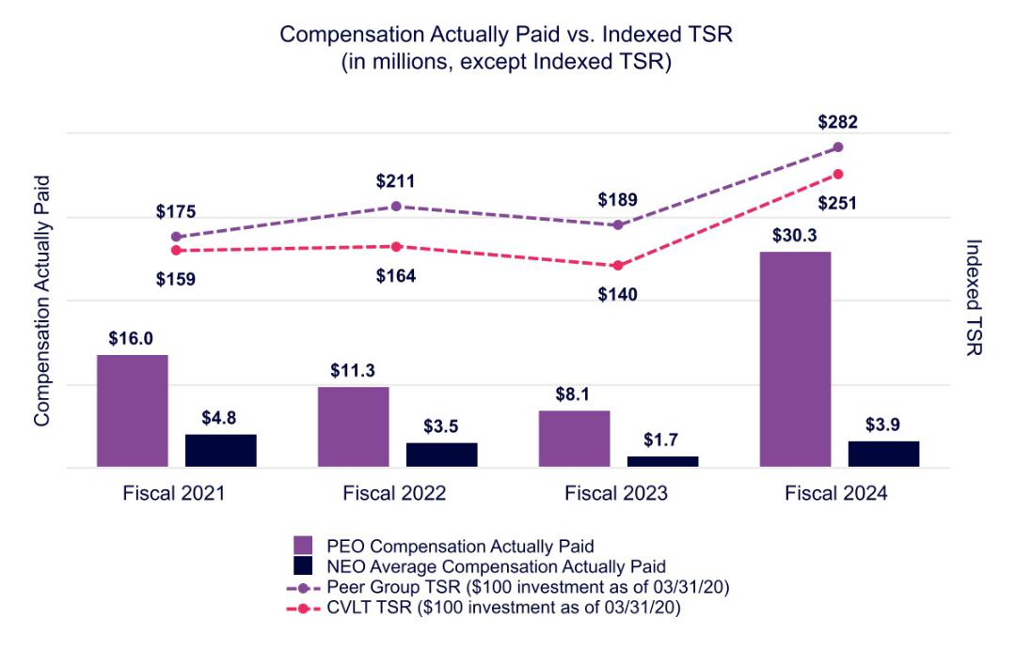

50 COMMVAULT SYSTEMS, INC. | 2024 PROXY STATEMENT

Table of Contents

COMPENSATION TABLES | PAY VERSUS PERFORMANCE

The following graph illustrates the relationship between compensation actually paid to our PEO and our non-PEO NEOs and our net income for the period presented in the Pay-Versus-Performance table.
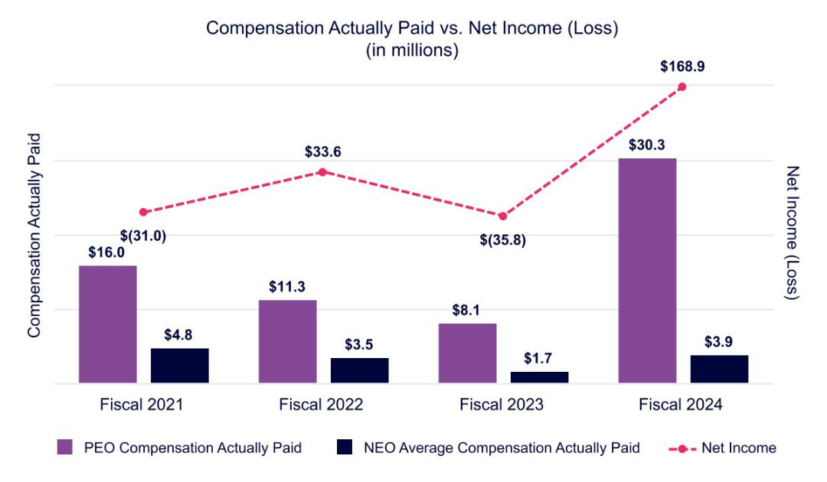

The following graph illustrates the relationship between compensation actually paid to our PEO and our non-PEO NEOs and our revenue for the period presented in the Pay-Versus-Performance table.
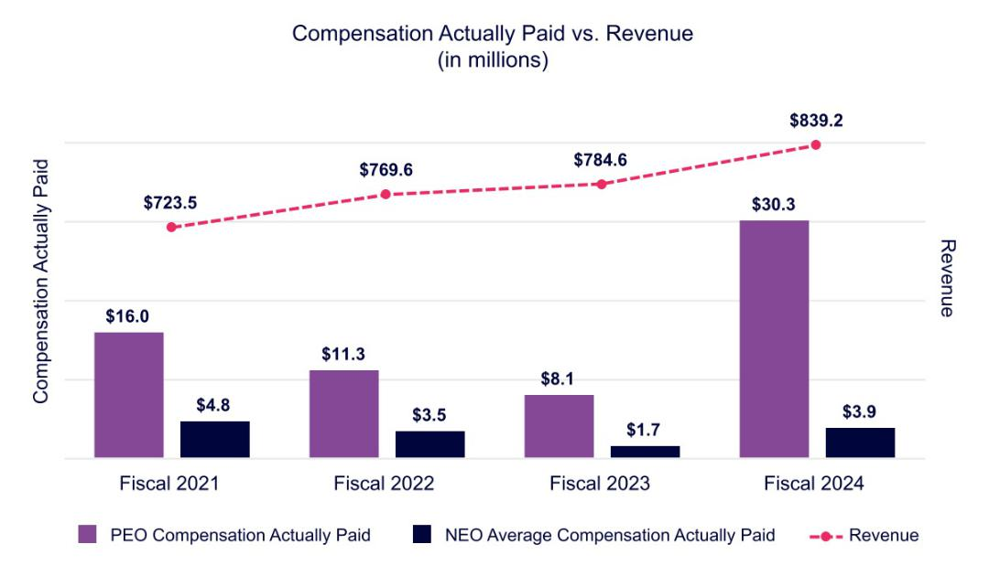

51 COMMVAULT SYSTEMS, INC. | 2024 PROXY STATEMENT

Table of Contents


The Audit Committee has reviewed and discussed Commvault’s audited financial statements for the fiscal year ended March 31, 2024 with our management. In addition, the Audit Committee has discussed with Ernst & Young LLP, our independent auditors, the matters required to be discussed by the applicable requirements of the Public Company Accounting Oversight Board (“PCAOB”) and the SEC.

The Audit Committee has received from the independent auditors written disclosures and the letter regarding the independent auditors’ communications with the Audit Committee concerning independence required by the applicable requirements of the PCAOB and has discussed with the independent auditors the firm’s independence.

The Audit Committee has considered whether the services rendered by our independent public accountants with respect to audit, audit-related, tax, and other non-audit fees are compatible with maintaining the firm’s independence.

Based on the review and discussions referred to above, the Audit Committee recommended to the Board of Directors that Commvault’s audited financial statements for the fiscal year ended March 31, 2024, be included in our Annual Report on Form 10-K for the fiscal year ended March 31, 2024, for filing with the SEC.

Audit Committee

Shane Sanders—Chair

Martha Bejar

Chuck Moran

Allison Pickens

52 COMMVAULT SYSTEMS, INC. | 2024 PROXY STATEMENT

Table of Contents


What am I voting on? |  | Vote Recommendation
As a matter of good corporate governance, we are asking stockholders to ratify the appointment of |  | FOR ratification of the selection of the
Ernst & Young LLP as Commvault’s independent auditors for fiscal year 2025. |  | auditors.

Financial statements of the Company and our consolidated subsidiaries will be included in our Annual Report furnished to all stockholders. The Audit Committee of the Board of Directors has appointed Ernst & Young LLP as independent public accountants for us to examine our consolidated financial statements for the fiscal year ending March 31, 2025 and has determined as a matter of good governance to seek stockholders’ ratification of the appointment. If the stockholders do not ratify the appointment, the Audit Committee will reconsider the appointment for the 2026 fiscal year, rather than the 2025 fiscal year, because of the difficulty and expense involved in changing independent auditors on short notice.

Ernst & Young LLP has been engaged as our principal independent public accountants continuously since fiscal year 1998. Representatives of Ernst & Young LLP are expected to attend the Annual Meeting. They will have the opportunity to make a statement if they wish and are also expected to be available to respond to appropriate questions.

Audit, Audit-Related, Tax, and All Other Fees

The following table summarizes the aggregate fees and expenses billed to us for the fiscal years ended March 31, 2024 and 2023, by our principal accounting firm, Ernst & Young LLP.

 | 2024 | 2023
 | (In thousands)
Audit fees | $2,497 | $2,266
Audit-related fees | 13 | 10
Tax fees | 1,207 | 1,149
All other fees | — | —
Total fees | $3,717 | $3,425

Audit Fees—all services necessary to perform an audit of the consolidated financial statements of our company presented in our annual report on Form 10-K; the reviews of our company’s quarterly reports on Form 10-Q; services in connection with statutory and regulatory filings or engagements; statutory audits; consents and review of documents filed with the SEC.

Audit-Related Fees—other assurance and related services that are reasonably related to the performance of an audit that are not included in Audit Fees, including fees related to the performance of audit and attest services not required by statute or regulation and subscription to EY’s online research tool.

Tax Fees—tax compliance; tax planning; and other tax advice.

All Other Fees—any other work that is not Audit, Audit-Related, or a Tax Service.

In considering the nature of the services provided by Ernst & Young LLP, the Audit Committee determined that such services are compatible with the provision of independent audit services. The Audit Committee discussed these services with Ernst & Young LLP and our management to determine that they are permitted under the rules and regulations concerning auditor independence promulgated by the SEC to implement the Sarbanes-Oxley Act of 2002.

53 COMMVAULT SYSTEMS, INC. | 2024 PROXY STATEMENT

Table of Contents

PROPOSAL NO. 3: RATIFICATION OF THE APPOINTMENT OF INDEPENDENT AUDITORS | | POLICY ON AUDIT COMMITTEE PRE-APPROVAL OF AUDIT AND NON-AUDIT SERVICES OF INDEPENDENT
 | AUDITOR

Policy on Audit Committee Pre-Approval of Audit and Non-Audit Services of Independent Auditor

The Audit Committee is responsible for appointing, setting compensation for, and overseeing the work of the independent auditor. The Audit Committee has established a policy regarding pre-approval of permissible non-audit services provided by the independent auditor. Generally, pre-approvals may be made by the chairperson of the Audit Committee and ratified by the full Audit Committee at its next meeting thereafter. All of the services performed by Ernst & Young LLP in the year ended March 31, 2024, were pre-approved in accordance with the pre-approval policy adopted by the Audit Committee.

The Board of Directors recommends that you vote FOR this proposal.

54 COMMVAULT SYSTEMS, INC. | 2024 PROXY STATEMENT

Table of Contents


This proxy statement is furnished in connection with the solicitation on behalf of the Board of Directors of Commvault Systems, Inc. of proxies to be voted at the Annual Meeting of Stockholders, including any adjournment or postponement thereof. This proxy statement is first being made available at www.edocumentview.com/CVLT, and we intend to begin distribution of the Notice Regarding the Availability of Proxy Materials to stockholders on or about June 25, 2024. A copy of our Annual Report on Form 10-K for the fiscal year ended March 31, 2024, which includes audited financial statements, is also being made available concurrently with the proxy statement at www.edocumentview.com/CVLT.

Time and Date: |  | Location: |  | Record Date:
Thursday, August 8, 2024 |  | Virtual only |  | June 13, 2024
10:00 a.m., Eastern Time |  | https://ir.commvault.com/news-and-events/annual-
 |  | meeting

How can I participate in the virtual annual meeting?

Our virtual annual meeting format will enable all stockholders to participate, regardless of their location. To participate in the Annual Meeting, please access the meeting website at https://ir.commvault.com/news-and-events/annual-meeting and follow the instructions found there. You will be required to establish your identity as a stockholder in order to vote during the meeting. Please have the control number found on your Notice of Internet Availability of Proxy Materials available.

Stockholders can submit questions for the Annual Meeting’s question and answer session prior to or during the meeting through https://ir.commvault.com/news-and-events/annual-meeting. Once the meeting has concluded, the webcast will be available for replay on the Investor Relations section of our website for 12 months.

Who is entitled to vote at the Annual Meeting?

The record date for determining stockholders entitled to vote at the Annual Meeting was June 13, 2024. On that date, 43,817,135 shares of Commvault common stock were outstanding, of which 43,767,630 were registered and entitled to vote. Each stockholder is entitled to one vote for each registered share of common stock held of record for each matter to be considered. A list of stockholders entitled to vote at the Annual Meeting will be available for examination by stockholders by arrangement made with Commvault during the 10 days preceding the meeting. Information regarding how to examine the

stockholder list is available at the meeting website at https://ir.commvault.com/news-and-events/annual-meeting.

The presence at the Annual Meeting, in person (including virtually) or by proxy, of holders of a majority of the issued and outstanding shares of common stock entitled to vote thereat as of the record date is considered a quorum for the transaction of business. If you submit a properly completed proxy or if you appear at the Annual Meeting to vote in person (including virtually), your shares of common stock will be considered part of the quorum. Abstentions and broker non-votes will be counted for the purpose of establishing a quorum.

55 COMMVAULT SYSTEMS, INC. | 2024 PROXY STATEMENT

Table of Contents

ADDITIONAL INFORMATION ABOUT THE ANNUAL MEETING

If you choose to vote your shares at the Annual Meeting, you will be required to provide your control number, which is included in the Notice Regarding the Availability of Proxy Materials that you received. If you hold your Commvault shares through a broker, bank, or other nominee, you may vote during the Annual Meeting only if you obtain a signed proxy from your bank, broker, or other nominee giving you the right to vote the shares. You will be asked to submit that proxy to Commvault via the email address provided on the meeting website at or prior to the Annual Meeting, along with an account statement or letter from the broker, bank, or other nominee indicating that you are the beneficial owner of the shares and that you were the beneficial owner of the shares on June 13, 2024.

What proposals will be considered at the Annual Meeting, and how does the Board recommend that I vote?

The following table summarizes the matters we expect to present to stockholders during the Annual Meeting.

 |  |  |  | Effect of
 |  | Board |  | abstentions,
Proposal | Voting options | Board | Vote required to pass | and broker
Proposal | Voting options | recommendation | Vote required to pass | non-votes(1)
Election of directors | FOR, AGAINST, or | FOR each | Each nominee must receive the affirmative vote of a | No effect
 | ABSTAIN for | nominee | majority of the votes cast on the proposal.
 | each nominee
Advisory vote on Commvault’s | FOR, AGAINST, or | FOR | As a non-binding, advisory vote, there is no specific | No effect
executive compensation | ABSTAIN |  | approval requirement. However, Commvault’s Board of
 |  |  | Directors will review and consider the outcome of this
 |  |  | advisory vote and will take it into account when making
 |  |  | future compensation decisions.
Ratification of the independent | FOR, AGAINST, or | FOR | The affirmative vote of a majority of the votes cast on | No effect
auditors | ABSTAIN |  | the proposal.

- For an explanation of broker non-votes, please see “How can I vote if I hold my Commvault stock through a broker?”

How can I vote if I do not plan to attend the Annual Meeting?

Registered stockholders of record may provide voting instructions before the Annual Meeting in one of three ways:

Mail Online Before the Meeting Telephone

Sign, date and return your proxy card in the enclosed envelope

Visit www.investorvote.com/CVLT and finish voting Call the telephone number on your proxy card before 3:00 a.m. EST on August 7, 2024.

All properly completed, unrevoked proxies received prior to the close of voting at the Annual Meeting will be voted in accordance with the instructions provided.

56 COMMVAULT SYSTEMS, INC. | 2024 PROXY STATEMENT

Table of Contents

ADDITIONAL INFORMATION ABOUT THE ANNUAL MEETING

How can I vote if I hold my Commvault stock through a broker?

If you hold your shares through a bank, broker, or other nominee (meaning you are the “beneficial owner” of shares owned by someone else) your broker will ask how you want your shares to be voted. If you give voting instructions, your broker will vote your shares as you direct. If you do not provide voting instructions, your broker is only permitted to vote your shares on Proposal No. 3 regarding ratification of the auditors. Brokers holding shares beneficially owned by their clients do not have the authority to cast votes with respect to the election of directors or executive compensation unless they have received instructions from the beneficial owner of the shares. If you do not provide instructions to your broker, your vote will not be counted with respect to Proposal No. 1 (the election of nine directors for a one-year term) or Proposal No. 2 (the advisory vote on executive compensation). This is called a “broker non-vote.” Please submit voting instructions to your broker by 11:59 p.m. Eastern time on August 7, 2024.

What if I return a proxy card but don’t mark all of my choices?

If we have a properly executed, unrevoked proxy card that does not specifically direct the voting of shares, the shares represented by such proxy will be voted (i) FOR the election of all nominees for election as director described in this proxy statement, (ii) FOR approval, on an advisory basis, of our executive compensation, (iii) FOR the ratification of the appointment of Ernst & Young LLP as our independent public accountants for the fiscal year ending March 31, 2025, and (iv) in accordance with the judgment of the individuals named on the proxy card as to such other matters as may properly come before the Annual Meeting.

What if I change my mind after I vote?

You can revoke your proxy at any time prior to the voting at the Annual Meeting by submitting a later-dated proxy (including a later-dated proxy via the Internet or telephone), by giving timely written notice of such revocation to our Corporate Secretary, or by attending the Annual Meeting and voting in person (virtually). If you attend the Annual Meeting and do not vote, it will not affect any previously submitted proxy or voting instructions.

Who is paying for this solicitation?

Commvault will pay all expenses related to the solicitation of proxies. Solicitation will be made by mail, and may be made by directors, officers, and employees, personally or by telephone, email, or other electronic means. Proxy cards and material also will be distributed to beneficial owners of our stock through brokers, custodians, nominees, and other like parties, and we expect to reimburse such parties for their charges and expenses.

How can I submit a proposal or a nomination for the 2025 Annual Meeting?

Stockholder proposals to be included in Commvault’s Proxy Statement

We must receive any stockholder proposal to be considered for inclusion in our proxy statement and form of proxy relating to the 2025 Annual Meeting of stockholders by February 25, 2025. Such submissions must comply with applicable SEC rules, including without limitation Rule 14a-8.

Stockholder nominations under proxy access

Our Bylaws permit qualifying stockholders to include a certain number of director nominees in our proxy statement. For any such nomination for our 2025 Annual Meeting to be timely, we must receive notice and certain required information at our principal executive offices between January 26, 2025 and February 25, 2025. Stockholders who make nominations pursuant to our proxy access provision should be mindful of the requirements set forth in our Bylaws, which are available on the Investor Relations section of our website.

57 COMMVAULT SYSTEMS, INC. | 2024 PROXY STATEMENT

Table of Contents

ADDITIONAL INFORMATION ABOUT THE ANNUAL MEETING

Other stockholder proposals

If you wish to submit a proposal for consideration at the 2025 Annual Meeting or to nominate a candidate for election as a director at that meeting without utilizing our proxy access provision, we must receive notice and certain required information at our principal executive offices no later than March 27, 2025. Any such notice must describe the proposal or nomination in sufficient detail for the matter to be summarized on the agenda for the meeting. Among other things, the notice must set forth:

- the name and address, as it appears on our books, of the stockholder who intends to make the proposal or nomination and the beneficial owner, if any, on whose behalf the nomination or proposal is made;
- a representation that the stockholder is a holder of record of our stock entitled to vote at the meeting and intends to appear in person or by proxy at the meeting to present such proposal or nomination;

- whether the stockholder plans to deliver or solicit proxies from other stockholders; and

- the class and number of our shares that the stockholder beneficially owns.

If you are nominating a candidate to be elected as a director, your notice must include the following additional information:

- the name and address of any person to be nominated,

- a description of all arrangements or understandings between you and each nominee and any other person or persons (naming such person or persons) pursuant to which the nomination or nominations are to be made,

- such other information regarding each nominee as would be required to be included in a proxy statement filed pursuant to Regulation 14A under the Securities Exchange Act of 1934, as amended,

- the consent of each nominee to serve as a director if so elected, and

- such other information as is set forth in our Bylaws, which are available on the Investor Relations section of our website.

In addition to satisfying the requirements of our Bylaws, including the earlier notice deadlines set out above and therein, to comply with universal proxy rules, stockholders who intend to solicit proxies in support of director nominees other than our nominees must also provide notice that sets forth the information required by Rule 14a-19 of the Securities Exchange Act of 1934, as amended, no later than June 9, 2025.

****

To the extent this proxy statement is incorporated by reference in any other filing by us under the Securities Act of 1933, as amended, or the Securities Exchange Act of 1934, as amended, the information included or incorporated in the section of this proxy statement entitled “Audit Committee Report” will not be deemed to be incorporated, unless specifically provided otherwise in such filing.

We will furnish without charge to each person whose proxy is being solicited, upon written request, a copy of our Annual Report on Form 10-K for the fiscal year ended March 31, 2024, as filed with the SEC, including the financial statements and schedules thereto. Requests for copies of such report should be directed to Danielle Sheer, Chief Legal and Trust Officer, and Corporate Secretary Commvault Systems, Inc., 1 Commvault Way, Tinton Falls, New Jersey 07724. A copy of our Annual Report on Form 10-K for the fiscal year ended March 31, 2024, is also being made available concurrently with the proxy statement at www.edocumentview.com/CVLT.


Danielle Sheer

Chief Legal and Trust Officer

58 COMMVAULT SYSTEMS, INC. | 2024 PROXY STATEMENT

Table of Contents


The following table provides a reconciliation of our reported GAAP results to the non-GAAP financial measures discussed above and used in certain of our named executive officers’ fiscal 2024 compensation arrangements. The following results are based on the accounting principles that were used to prepare the fiscal 2024 consolidated financial statements included in our Annual Report on Form 10-K for the fiscal year ended March 31, 2024. Amounts below are in thousands, except per share data.

 | Fiscal Year Ended March 31,
 | 2024 | 2023
Non-GAAP financial measures and reconciliation:
GAAP income (loss) from operations | $75,355 | $(15,885)
Noncash stock-based compensation(1) | 93,034 | 103,139
FICA and payroll tax expense related to stock-based compensation(2) | 3,285 | 2,465
Restructuring(3) | 4,548 | 15,452
Amortization of intangible assets(4) | 1,250 | 1,250
Headquarters impairment(5) | — | 53,481
Non-GAAP income from operations | $177,472 | $159,902
GAAP net income (loss) | $168,906 | $(35,774)
Noncash stock-based compensation(1) | 93,034 | 103,139
FICA and payroll tax expense related to stock-based compensation(2) | 3,285 | 2,465
Restructuring(3) | 4,548 | 15,452
Amortization of intangible assets(4) | 1,250 | 1,250
Headquarters impairment(5) | — | 53,481
Gain on escrow payment(6) | (1,670) | —
Non-GAAP provision for income taxes adjustment(7) | (134,989) | (22,904)
Non-GAAP net income | $134,364 | $117,109
Non-GAAP free cash flow reconciliation:
GAAP cash provided by operating activities | 203,798 | 170,288
Capital expenditures | (4,086) | (3,241)
Non-GAAP free cash flow | $199,712 | $167,047

- Represents noncash stock-based compensation charges associated with restricted stock units granted under our 2016 Incentive Plan and purchase rights issued under our Employee Stock Purchase Plan, exclusive of stock-based compensation expense related to Commvault’s restructuring activities described below in Note 3.

- Represents additional FICA and related payroll tax expenses incurred by Commvault when employees exercise in-the-money stock options or vest in restricted stock awards.

- These restructuring charges relate primarily to severance and related costs associated with headcount reductions and stock-based compensation related to modifications of existing unvested awards granted to certain employees impacted by the restructuring plans.

- Represents noncash amortization of intangible assets.

- Represents noncash impairment charges related to the pending sale of Commvault’s owned corporate headquarters.

- Represents a non-refundable escrow payment received related to the expiration of the exclusivity agreement for the pending sale of Commvault’s owned corporate headquarters.

- The provision for income taxes is adjusted to reflect Commvault’s estimated non-GAAP effective tax rate of 27%. During the fourth quarter of fiscal 2024, the Company reversed its valuation allowance, resulting in a tax benefit of $85 million for the fiscal year ended March 31, 2024.

59 COMMVAULT SYSTEMS, INC. | 2024 PROXY STATEMENT

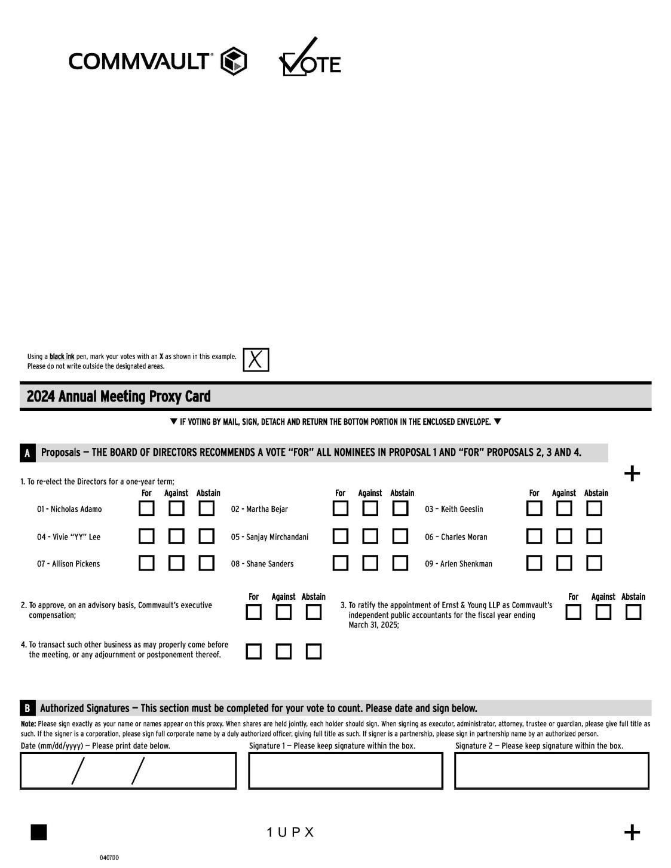

60 COMMVAULT SYSTEMS, INC. | 2024 PROXY STATEMENT



61 COMMVAULT SYSTEMS, INC. | 2024 PROXY STATEMENT

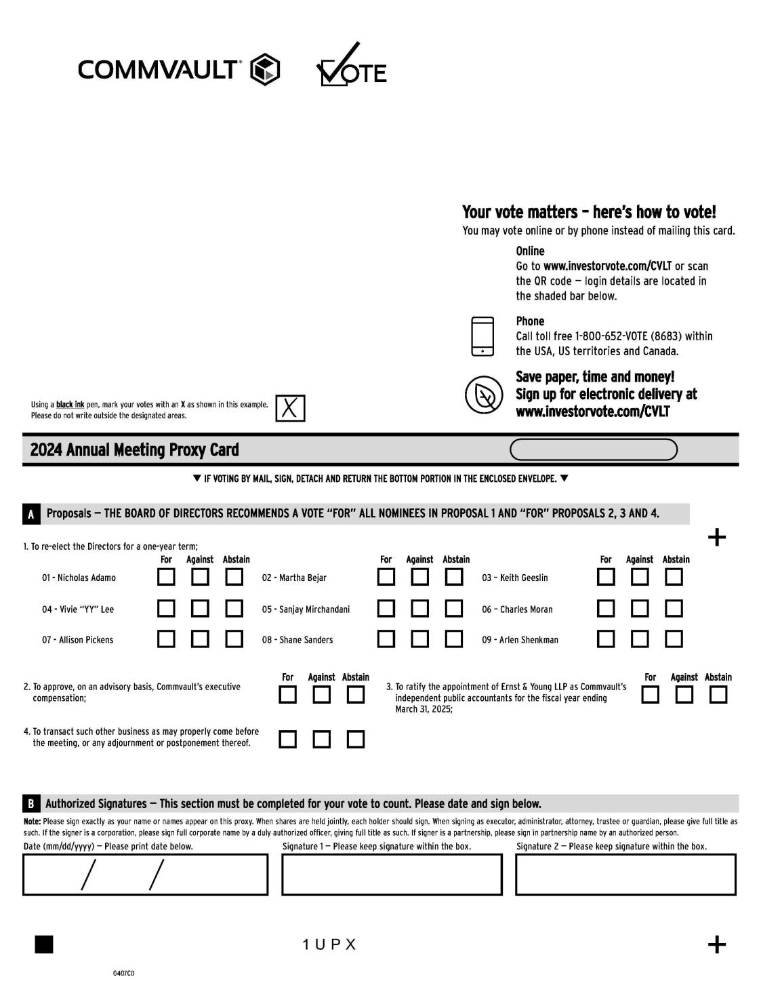

62 COMMVAULT SYSTEMS, INC. | 2024 PROXY STATEMENT

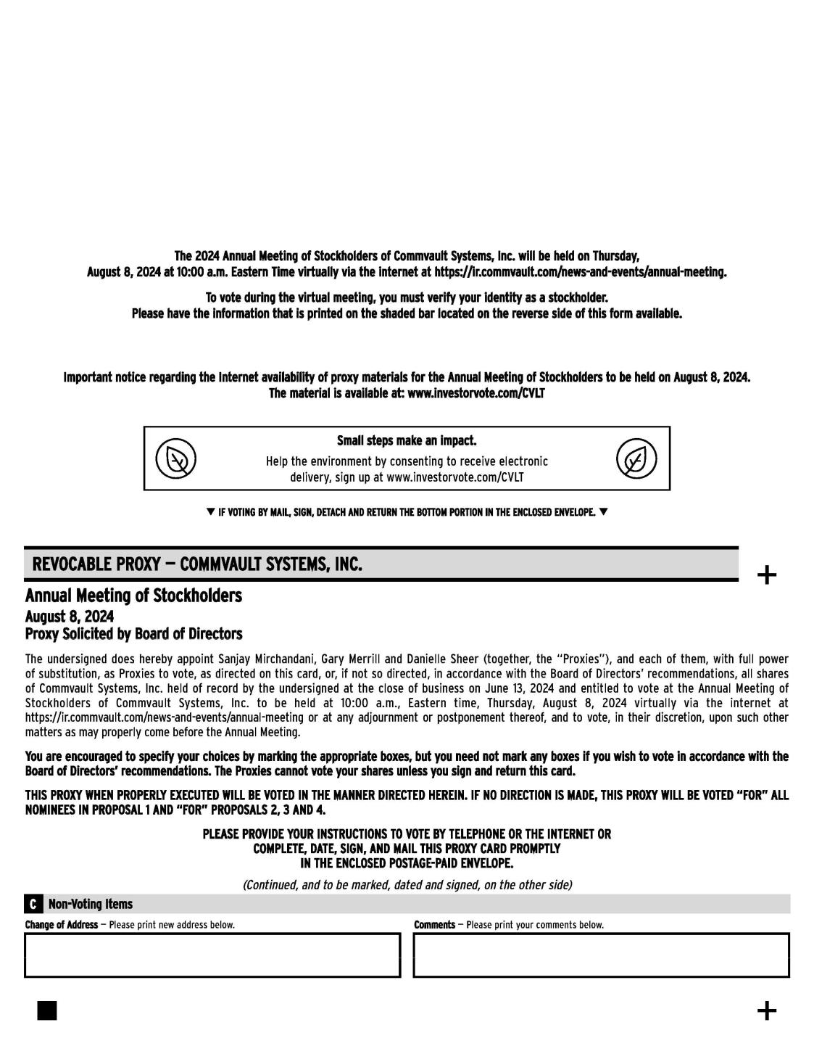

63 COMMVAULT SYSTEMS, INC. | 2024 PROXY STATEMENT

commvault.com | 888.746.3849 | get-info@commvault.com

